**IN THE CIRCUIT COURT OF THE STATE OF OREGON**

**FOR THE COUNTY OF MULTNOMAH**

|  |  |  |
| --- | --- | --- |
| LEROI ESPIRIQUETZAL, *An Individual,*    Plaintiff,  vs.  QUALITY LOAN SERVICE CORPORATION OF WASHINGTON,  CERTIFICATEHOLDERS OF MORGAN STANLEY IXIS REAL ESTATE CAPITAL TRUST 2006-1, MORTGAGE PASS-THROUGH CERTIFICATES, SERIES 2006-1  MORGAN STANLEY IXIS REAL ESTATE CAPITAL TRUST 2006-1, *In Its Capacity As Issuing Entity for Morgan Stanley IXIS Real Estate Capital Trust 2006-1, Mortgage Pass-Through Certificates, Series 2006-1,*  MORGAN STANLEY ABS CAPITAL I INC.,  *In Its Capacity As Depositor for Morgan Stanley IXIS Real Estate Capital Trust 2006-1 Mortgage Pass-Through Certificates, Series 2006-1,*  WELLS FARGO BANK, NATIONAL ASSOCIATION, *In Its Capacity As Master Servicer, Securities Administrator and Servicer, for Morgan Stanley IXIS Real Estate Capital Trust 2006-1 Mortgage Pass-Through Certificates, Series 2006-1,*  DEUTSCHE BANK NATIONAL TRUST COMPANY, *In Its Capacity As Trustee for Morgan Stanley IXIS Real Estate Capital Trust 2006-1 Mortgage Pass-Through Certificates, Series 2006-1,*  MCCARTHY & HOLTHUS, LLP,  REALTY TRUST GROUP, INC.,  DON MCCREDIE, *In His Official Capacity As Principal Broker for Realty Trust Group,*  FATCO HOLDINGS, LLC, *A Delaware Domestic Limited Liability Corporation,*  MICHAEL REESE, *In His Official Capacity as Multnomah County Sheriff,*    KATHERINE BROWN, *In Her Official Capacity as Governor of the State of Oregon,*  WALTER JOSEPH CLAYTON III, *In His Official Capacity as Chairman of the United States Securities and Exchange Commission*,  STEVEN TERNER MNUCHIN, *In His Official Capacity as Secretary of the United States Department of the Treasury,*  DONALD JOHN TRUMP, *In His Official Capacity As President of the United States*,  Defendants. | )  )  )  )  )  )  )  )  )  )  )  )  )  )  )  )  )  )  )  )  )  )  )  )  )  )  )  )  )  )  )  )  )  )  )  )  )  )  )  )  )  )  )  )  )  )  )  )  )  )  )  )  )  )  )  )  )  )  )  )  )  )  )  )  )  )  )  ) | Case no: 17CV55601  **First Amended Complaint For**  **1. Racketeering Conspiracy to Defraud;**  **2. Wrongful Foreclosure;**  **3. Abusive Debt Collection Practices;**  **4. Reconveyance of Deed of Trust;**  **5. Declaratory and Injunctive Relief; and**  **6. Damages**      **DEMAND FOR JURY TRIAL** |

Plaintiff LeRoi Espiriquetzal, a private individual, alleges:

**I. NATURE OF THE ACTION.**

1. This is a “public interest” civil action alleging violations of 15 USCS §§ 1692 *et seq.*; Chapter 86 of Title 9 Oregon Revised Statutes (ORS) and Chapter 105 of Title 10 ORS.

2. Plaintiff seeks Federal and State damages and injunctive relief; State and Federal statutory penalties and relief; and summary and declaratory judgment.

**II. PREEMPTION EXCEPTION TO STATE LAWS.**

3. Congress expressly provided under 15 U.S.C. §1681t that every credit reporting agency subject to Chapter 41 of Title 15 shall be accountable under State laws enacted “for the prevention or mitigation of identity theft, except to the extent that those laws are inconsistent with any provision of [subchapter III], and then only to the extent of the inconsistency.”

4. The Defendants are subject to the Clayton Act, 15 U.S.C. § 12 *et seq.*, for purposes of the antitrust laws as defined in such sections and section 5 of the Federal Trade Commission Act, 15 U.S.C. § 45, *et seq.*, to the extent that such section 5 applies to unfair methods of competition.

5. Section 24 of the Clayton Act provides for the liability of the directors and agents, to wit:

“Whenever a corporation shall violate any of the penal provisions of the antitrust laws, such violation shall be deemed to be also that of the individual directors, officers, or agents of such corporation who shall have authorized, ordered, or done any of the acts constituting in whole or in part such violation, and such violation shall be deemed a misdemeanor, and upon conviction therefor of any such director, officer, or agent he shall be punished by a fine of not exceeding $5,000 or by imprisonment for not exceeding one year, or by both, in the discretion of the court.” (2015 ed.)

6. Oregon’s nonjudicial foreclosure statutes, Chapter 86 of Title 9, and its unlawful detainer statutes, Chapter 105 of Title 10, operate to bring Defendant and the State of Oregon into an undeniable public-private partnership that creates privity under *Stacy v. Thrasher,* 47 U.S. 6 How. 44, 60 (1848), and brings them within the rule of *Shelley v. Kraemer,* 334 U.S. 1, 13-14 (1948); *Sniadach v. Family Fin. Corp.,* 395 U.S. 337, 338-39 (1969); *Fuentes v. Shevin,* 407 U.S. 67, 70-71 (1972); *North Georgia Finishing, Incorporated v. Di-Chem, Inc.,* 419 U.S. 601 (1975); *Lugar v. Edmondson Oil Company,* 467 U.S. 922, 934, 940-42 (1980); and *Edmondson v. Leesville Concrete Company,* 500 U.S. 614 (1991), which hold that a private party becomes a state actor if he or she uses a state procedure requiring state intervention, ratification or enforcement of the private conduct.

**III. JURISDICTION AND VENUE.**

7. The violations alleged in this Complaint have been made and are being committed in whole or in part in, or affect, in whole or in part, Multnomah County Oregon.

8. Authority of Plaintiff to commence this action in the Circuit Court of the State of Oregon for the County of Multnomah is conferred by 15 U.S.C. § 1692k(d), 28 U.S.C. § 1367; and Oregon Revised Statutes (ORS) Chapters 86 and 106.

9. Venue is proper under 15 U.S.C. § 1692k(d), 28 U.S.C. § 1367 and Chapters 86 and 106 ORS because Multnomah County is where a substantial part of the events giving rise to the claims occurred; and or there is no other Circuit in which all the claims can otherwise be brought to avoid a multiplicity of suits in multiple State and Federal districts.

10. The real property subject to this action is located within Multnomah County Washington and is described as follows:

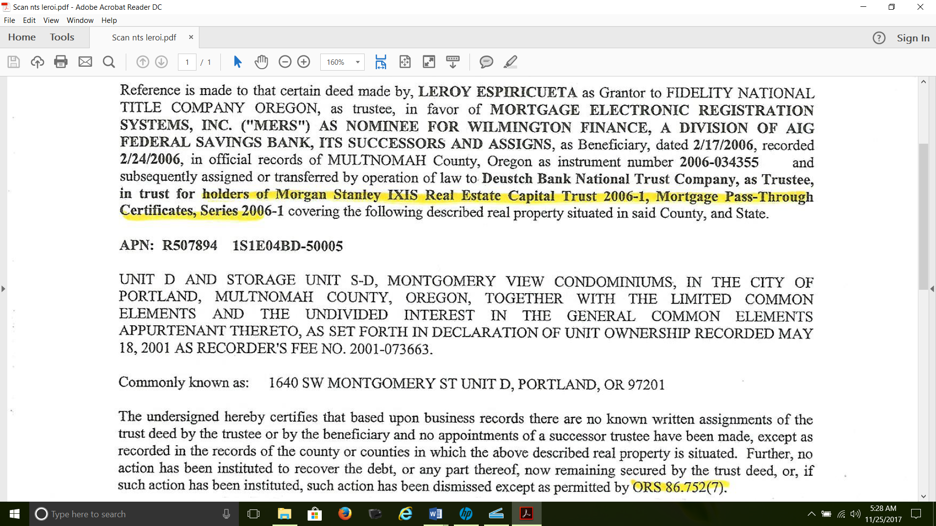

**IV. PARTIES.**

11. Plaintiff LeRoi Espiriquetzal is a private individual and maintains a permanent residence within Multnomah County.

12. Defendant Quality Loan Service Corporation of Washington is a Washington State domestic for-profit corporation. Defendant Quality Loan Service Corporation of Washington is subject to the Constitution and Laws of the United States.

13. Defendant Certificateholders of Morgan Stanley IXIS Real Estate Capital Trust 2006-1 are individuals and entities who have made financial investments in Defendant Morgan Stanley IXIS Real Estate Capital Trust 2006-1. Defendant Certificateholders of Morgan Stanley IXIS Real Estate Capital Trust 2006-1 are subject to the Constitution and Laws of the United States.

14. Morgan Stanley IXIS Real Estate Capital Trust 2006-1 is the exact name of the “issuing entity” identified as a Defendant in this action. Defendant Morgan Stanley IXIS Real Estate Capital Trust 2006-1 (“Trust 2006-1”) is organized as an “asset-backed securities” pursuant to Sections 13 and 15(d) of the Securities Exchange Act of 1934. The State or other jurisdiction for Trust 2006-1 is Delaware; the Securities Exchange Commission’s File Number is 333-130694-08; and the Internal Revenue Service Employer Identification No. is 13-3939229. Defendant Trust 2006-1 has listed its mailing and business address with the Securities Exchange Commission as: 1585 Broadway, 2nd Floor, New York, NY 10036. Defendant Morgan Stanley IXIS Real Estate Capital Trust 2006-1 is subject to the Constitution and Laws of the United States.

15. Morgan Stanley ABS Capital I Inc. is the exact name of Defendant Morgan Stanley IXIS Real Estate Capital Trust 2006-1 “Depositor” identified as a Defendant in this action as specified in its charter. Defendant Morgan Stanley ABS Capital I Inc. is subject to the Constitution and Laws of the United States.

16. Wells Fargo Bank National Association is the exact name of the Master Servicer, Securities Administrator and Servicer for Defendant Morgan Stanley IXIS Real Estate Capital Trust 2006-1 identified as a Defendant in this action. Defendant Wells Fargo Bank National Association is subject to the Constitution and Laws of the United States.

17. Deutsche Bank National Trust Company is the exact name of the “Trustee” of Defendant

Morgan Stanley IXIS Real Estate Capital Trust 2006-1 identified as a Defendant in this action.

Defendant Deutsche Bank National Trust Company (“Deutsche Bank”) is a wholly owned subsidiary of Deutsche Bank AG. Defendant Deutsche Bank is subject to the Constitution and Laws of the United States.

18. Defendant McCarthy & Holthus, LLP (“McCarthy Holthus”) is a “multi-state” law firm representing financial institutions specializing in mortgages in default as well as a variety of banking law matters in Arizona, California, Colorado, Idaho, New Mexico, Nevada, Oregon, Texas and Washington. McCarthy Holthus, through its attorneys, further assist mortgage lenders in obtaining possession of property following recovery of an asset. McCarthy Holthus untruthfully claims on its website that its foreclosure service complies with “all federal and state laws”, when in truth, its services never fully complied with Federal homeless reformation laws, Public Law 111-22 (“Pub. L. 111-22”), Plaintiff’s Exhibit 7, enacted on May 20, 2009, and Oregon’s nonjudicial foreclosure and unlawful detainer laws, to wit:



<http://www.mccarthyholthus.com/practice.aspx>

19. McCarthy Holthus attorneys Thomas Holthus and Kevin McCarthy are Managing Members of Defendant Quality Loan. McCarthy Holthus is often co-located with its client, Defendant Quality Loan, in several States and maintains an Oregon presence with Defendant Quality Loan at: 920 SW 3rd Ave, 1st Floor, Portland, OR 97204, Fax: (971) 201-3202. Defendant McCarthy Holthus and its attorneys are subject to the Constitution and Laws of the United States.

20. Realty Trust Group, Inc. is the exact name of the corporation identified as a Defendant in this action as specified in its Article of Incorporation filed with the Oregon Secretary of State on December 17, 1997. Realty Trust Group, Inc. (“Realty Trust”) is an Oregon domestic corporation formed as “a locally-owned real estate brokerage” firm. Sue Coon, Jan Caplener, Brian Pienovi and Todd Prendergast, who is also listed as the Registered Agent who can be found at the following address: 1220 NW Lovejoy, Suite 130, Portland, OR 97209. Realty Trust employs approximately 160 agents with an average of 12 years of experience in the real estate industry. Defendant Realty Trust and its real estate agents are subject to the Constitution and Laws of the United States.

21. Defendant Don McCredie (“McCredie”) is a “Principal Broker” assigned to Defendant Realty Trust’s Lake Oswego office located at: 600 A Avenue, Lake Oswego, OR 97034; Tel: (503) 781-7158/ (503) 675-3300. On December 29, 2017, Defendant McCredie, who identified himself through a Realty Trust business card, Plaintiff’s Exhibit 6, informed Plaintiff that he was representing the “bank” that desired to offer Plaintiff move-out money in exchange for the keys or the bank would “evict,” which would violate Pub. Law 111-22. See Plaintiff’s Exhibits 6 and 7. Defendant McCredie is subject to the Constitution and Laws of the United States.

22. Defendant FATCO Holdings, LLC is a Delaware domestic LLC, Delaware file number 4408365 and a subsidiary of First American Financial Corporation assigned Securities and Exchange Commission file number 001-34580 and IRS FEIN No. 26-1911571. Defendant FATCO Holdings, LLC was aware that aiding and abetting nonjudicial foreclosure sales would violate Pub. Law 111-22 and other laws of the United States and the State of Oregon. Defendant FATCO Holdings, LLC is subject to the Constitution and Laws of the United States.

23. Defendant Michael Reese (“Reese”) is the Multnomah County Sheriff whose office is routinely ordered by the State of Oregon to wrongfully and by force evict hundreds of individuals from their homes or rental apartments in direct violation of the Constitution of the United States and Pub. L. 111-22. Defendant Reese is subject to the Constitution and Laws of the United States.

24. Defendant Katherine Brown (“Brown”) is the Governor of the State of Oregon. In 1991, Brown was appointed to the Oregon House of Representatives. In 1996, she was elected to the Oregon State Senate. In 1998 she was elected as the State Senate Democratic Leader. In 2004, Oregon’s State Senators made her the first woman to serve as Oregon’s Senate Majority Leader. In 2009, Brown introduced and passed House Bill 2005 which was designed to crack down on fraud and abuse in the initiative and referendum system. It gave Brown, who later became Secretary of State in 2009, additional powers to prosecute fraud by the Oregon Secretary of State.

25. Brown has served as Governor of Oregon from 2015 to present. At no time during her tenure as Oregon’s Governor has Brown sought to bring the State’s nonjudicial foreclosure and unlawful detainer systems into compliance with the Constitution of the United States and Pub. L. 111-22. Defendant Brown is subject to the Constitution and Laws of the United States.

26. Walter Joseph Clayton III (“Clayton”) is the Chairman of the United States Securities and Exchange Commission (“SEC”). He earned his law degree from the University of Pennsylvania Law School in 1993 and from 1993 to 1995, he clerked for Federal judge Marvin Katz, judge of the United States District Court for the Eastern District of Pennsylvania. During the financial crisis of 2007 and 2008, Clayton advised Bear Stearns in its fire sale to JPMorgan Chase and Barclays Capital in the purchase of Lehman Brothers’ assets following their bankruptcy.

27. In March 2017, Defendant Clayton disclosed to the U.S. Office of Government Ethics that his clients have included Deutsche Bank and Ocwen Financial Corporation—clients that faced intense government scrutiny during the financial crisis.

28. In or about 2009, Ocwen Financial Corporation became a participant in the U.S. Treasury Department’s Home Affordable Modification Program (HAMP). In 2011, Ocwen reported that it had modified more than 200,000 troubled loans since the mortgage crisis began. Ocwen failed to report that these modifications did not fully comply with Pub. Law 111-22.

29. On December 20, 2013, Oregon Attorney General Ellen F. Rosenblum announced Oregon’s participation in a $2.1 billion settlement with Ocwen Financial Corporation and its subsidiary Ocwen Loan Servicing. Named as Defendants were: BANK OF AMERICA CORPORATION; BANK OF AMERICA, N.A.; BAC HOME LOANS SERVICING, LP f/k/a COUNTRYWIDE HOME LOANS SERVICING, LP; COUNTRYWIDE HOME LOANS, INC.; COUNTRYWIDE FINANCIAL CORPORATION; COUNTRYWIDE MORTGAGE VENTURES, LLC; COUNTRYWIDE BANK, FSB; CITIGROUP INC.; CITIBANK, N.A.; CITIMORTGAGE, INC.; J.P. MORGAN CHASE & COMPANY; JPMORGAN CHASE BANK, N.A.; RESIDENTIAL CAPITAL, LLC; ALLY FINANCIAL, INC.; GMAC MORTGAGE, LLC; GMAC RESIDENTIAL FUNDING CO. LLC; WELLS FARGO & COMPANY and WELLS FARGO BANK, N.A.

30. After becoming aware of the fraud committed against the United States and the State of Oregon and its homeowners, Clayton, Oregon and its Attorney General refused to reform the State’s nonjudicial foreclosure and unlawful detainer systems to comply with the Constitution of the United States and Pub. L. 111-22. Defendant Clayton is subject to the Constitution and Laws of the United States.

31. Defendant Steven Terner Mnuchin (“Mnuchin”) is the Secretary of the United States Department of the Treasury. As Secretary of the Treasury, Defendant Mnuchin is responsible for the executive branch agency whose mission is to maintain a strong economy, foster economic growth, and create job opportunities by promoting the conditions that enable prosperity and stability at home and abroad. Mnuchin is also responsible for strengthening national security by combating economic threats and protecting the integrity of our financial system as well as managing the U.S. Government’s finances.

32. When enacting Pub. Law 111-22, Congress specifically tasked Mnuchin with the duty to implement Congress’ goals outlined therein. Defendant Mnuchin is aware that home foreclosures and rental evictions have continued unabated in direct violation of Pub. Law 111-22, and he has failed to investigate and cause the Several States to reform their nonjudicial foreclosure and unlawful detainer laws. Defendant Mnuchin is subject to the Constitution and Laws of the United States.

33. Donald John Trump (“Trump”) was inaugurated as the 45th President of the United States on January 20, 2017. Among other things, President Trump was advised that the previous Administration had been unconstitutionally paying subsidies to insurance companies to keep “Obamacare” afloat by redirecting profits from Freddie Mac and Fannie Mae.

34. On February 27, 2017, Alex Jones and Jerome Corsi of Infowars.com reported in an exclusive story providing evidence that: “Obama Illegally Robbed Fannie, Freddie to Fund Obamacare, Obama diverted money from low-income housing to keep Obamacare alive.”[1] Jones and Corsi reported that:

“Federal court litigation provides evidence the Obama administration illegally diverted taxpayer funds that had not been appropriated by Congress in an unconstitutional scheme to keep Obamacare from imploding. In 2016, a U.S. District judge caught the Obama administration’s Health and Human Services Department acting unconstitutionally and therefore put an end to the illegal diversion of taxpayer funds, but the Obama administration didn’t stop there. A key date is May 12, 2016. That was the day when U.S. District Judge Rosemary Collyer, in the case [U.S. House of Representatives v. Burwell](http://www.scotusblog.com/wp-content/uploads/2016/05/HofR-challenge-to-ACA-DCt-5-12-16.pdf), (130 F. Supp. 3d 53, U.S. District Court for the District of Columbia), ruled against Health and Human Services Secretary Sylvia Matthews Burwell…. The Obama administration took this action, the so-called “Net Worth Sweep,” without any Congressional authority to do so. The result was that the U.S. Treasury “found” a way to sweep 100% of Fannie and Freddie profits into the Treasury’s “general fund,” leaving the giant mortgage GSEs vulnerable to the need for another government bailout should another disruption occur in the nation’s economy. Because of this decision, the Obama administration on its own authority simply decided to discontinue paying dividends to private and institutional owners of Fannie and Freddie common and preferred stock.”

35. During the financial crisis of 2008, caused in part by the collapse of the subprime mortgage market, the Federal government seized Fannie Mae and Freddie Mac and placed them into government “conservatorship.”

36. In October 2017, President Trump ended subsidy payments to health insurance companies based on the findings of the 2014 lawsuit filed by House Republicans. In a pair of Tweets, President Trump celebrated ending the unconstitutional theft of profits from Fannie Mae and Freddie Mac to make unconstitutional payment of insurance subsidies:



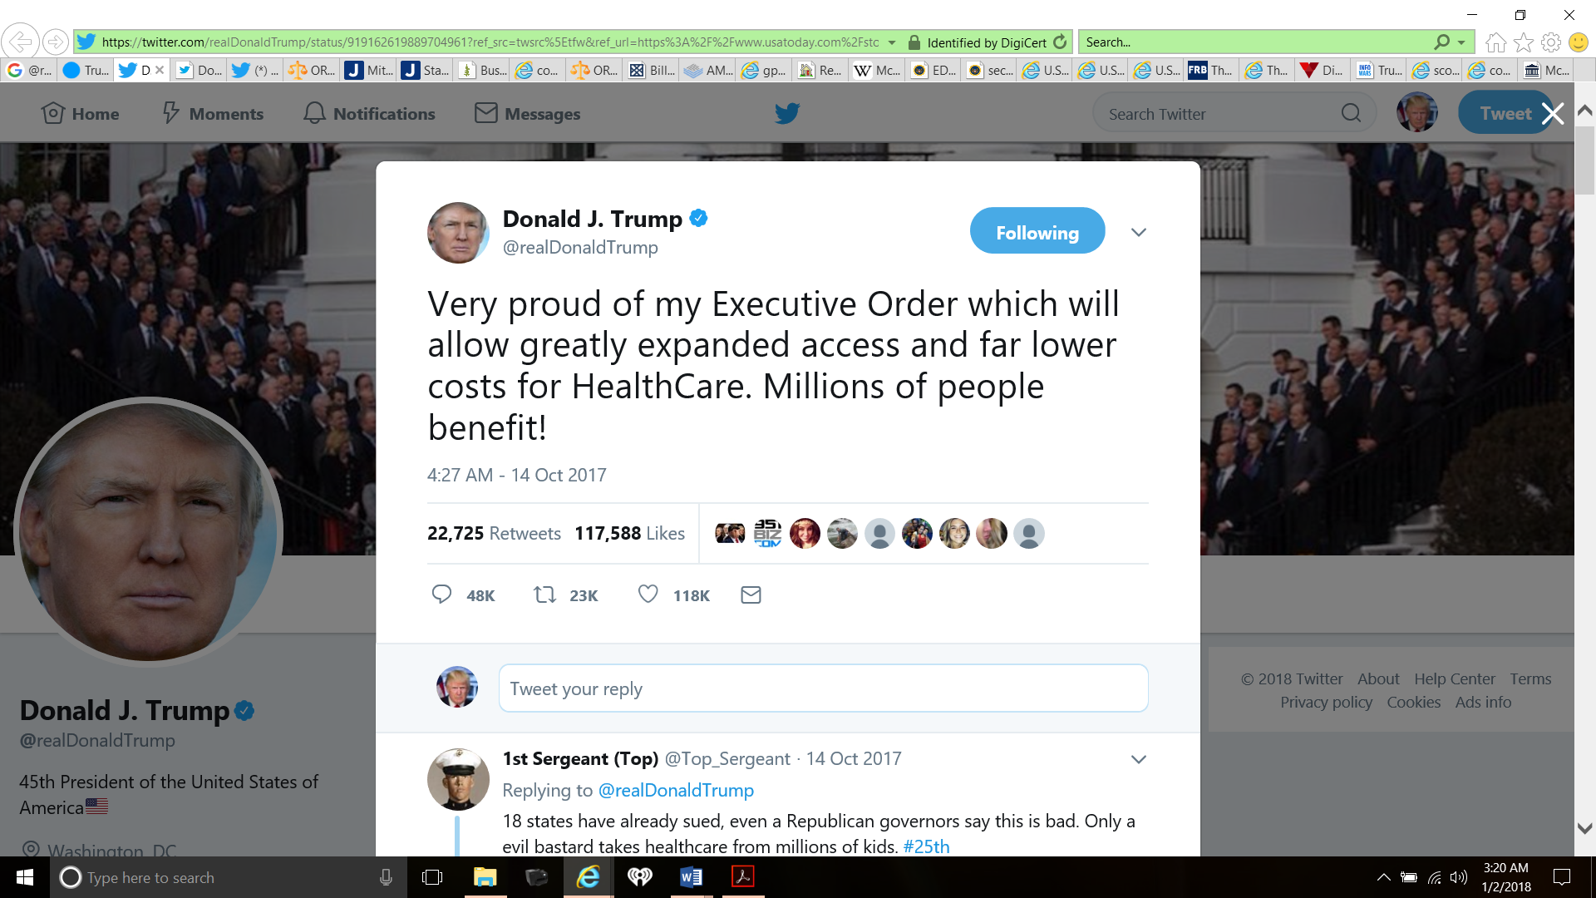

37. The findings of Judge Rosemary M. Collyer agreed that Congress failed to appropriate any money for the cost-sharing insurance subsidies. U.S. Speaker Paul Ryan said, “the Obama administration had usurped the authority of Congress by paying the subsidies” and further explained, “the power of the purse belongs to Congress, not the executive branch”.

38. After learning of the nationwide mortgage settlements and the theft of profits from Fannie Mae and Freddie, President Trump also became aware that home foreclosures and rental evictions have continued unabated in direct violation of Pub. Law 111-22, and he has failed to investigate and cause the Several States to reform their nonjudicial foreclosure and unlawful detainer laws.

39. The failure of all Defendants to reform their practices and procedures to comply with Pub. Law 111-22 is the direct and primary cause of Plaintiff being wrongfully foreclosed against on December 28, 2017. President Trump, like the other Defendants, is subject to the Constitution and Laws of the United States.

**V. RELEVANT BACKGROUND INFORMATION.**

40. A unique feature of Republican Rome’s political algorithm was its “cash- and credit-using system” which implemented the concept of “money,” the first effect of which “was to give freedom of movement and leisure to a number of people who could not otherwise have enjoyed these privileges.”

41. The People of the United States adopted this peculiar power and value of money to mankind when ordaining the Coinage Clause, Article I, § 8 Clause 5; Borrowing Clause, Article I, § 8, Clause 2; Necessary and Proper Clause, Article I, § 8, Clause 18; State Coinage Clause, Article I, § 10, Clause 1; and State Obligation of Contract Clause, Article I, § 10, Clause 1 of the Federal Constitution.

42. On February 24, 2006, Plaintiff, for valuable consideration of $236,900.00, was granted a Statutory Warranty Deed for the real property described in paragraph 10, *supra,* which was subsequently indexed and verified by Multnomah County Oregon and assigned Document No. 2006-034354. See, Plaintiff’s Exhibit 1.

43. In February 2006, Plaintiff also executed an Adjustable Rate Balloon Note (“Note”) for $189,520.00 in favor of the Lender, Wilmington Finance, Inc. (WFI), a division of AIG Federal Savings Bank (FSB), which was assigned Loan No. 4700003345. Plaintiff’s Exhibit 2.

44. As security for the Note, Plaintiff executed a Deed of Trust (“DOT”), Multnomah County Document No. 2006-034355, Plaintiff’s Exhibit 3, which the Lender, WFI, required Mortgage Electronic Registration Systems, Inc. (“MERS”) be named “the beneficiary under this Security Instrument” in contravention of subdivision (2) of ORS 86.705, which provides that:

“’Beneficiary” means a person named or otherwise designated in a trust deed as the person for whose benefit a trust deed is given, or the person’s successor in interest, and who is not the trustee unless the beneficiary is qualified to be a trustee under ORS 86.790 (1)(b)(D).”

45. On March 26, 2009, MERS, in its capacity as “beneficiary” of Plaintiff’s Deed of Trust, recorded an “Assignment of Deed of Trust, Multnomah County Records No. 2009-039776, wherein it claimed it was assigning Plaintiff’s Note and Deed of Trust to “Deutsche Bank National Trust Company, as Trustee for Morgan Stanley IXIS Real Estate Capital Trust 2006-1 Mortgage Pass-Through Certificates, Series 2006-1 (“2006-1 Trust”), whose address is 10790 Rancho Bernardo Road San Diego, CA 92127.” Plaintiff’s Exhibit 5.

46. The June 1, 2006 Pooling and Servicing Agreement (“PSA”) for the 2006-1 Trust named the following entities as parties to this Agreement: (1) MORGAN STANLEY ABS CAPITAL I INC., Depositor; (2) WELLS FARGO BANK, NATIONAL ASSOCIATION, Master Servicer, Securities Administrator and Servicer; (3) SAXON MORTGAGE SERVICES, INC., Servicer; (4) JPMORGAN CHASE BANK, NATIONAL ASSOCIATION, Servicer; (5) HOMEQ SERVICING CORPORATION, Servicer; (6) FIRST NLC FINANCIAL SERVICES, LLC,

Responsible Party; (7) DECISION ONE MORTGAGE COMPANY, LLC, Responsible Party; (8) WMC MORTGAGE CORP., Responsible Party; (9) DEUTSCHE BANK NATIONAL TRUST COMPANY, Trustee, which is a wholly owned subsidiary of Deutsche Bank AG.; and (10) IXIS REAL ESTATE CAPITAL INC., a Sponsor.

47. In *Fannie Mae v. Goodrich*, 275 Ore. App. 77, 364 P.3d 696 (2015), the Oregon Court of Appeals, in affirming the trial court’s ruling that the nonjudicial foreclosure was invalid, held that the “beneficiary” under the Oregon Trust Deed Act (OTDA) must be:

“[T]he lender to whom the obligation that a trust deed secures is owed or the lender’s successor in interest. Thus, an entity like [MERS], which is not a lender, may not be a trust deed’s beneficiary, unless it is a lender’s successor in interest.”[2]

48. In August 2017, notwithstanding subdivision (2) of ORS 86.705 and the rulings of the Courts in *Fannie Mae v. Goodrich*, 275 Ore. App. 77, 364 P.3d 696 (2015), *Brandrup v. ReconTrust Co.,* 353 Ore. 668, 303 P3d 301 (2013) and *Niday v. GMAC Mortgage, LLC,* 353 Ore. 648, 302 P3d 444 (2013), Defendant Quality Loan Service Corporation of Washington served Plaintiff with a copy of a “Trustee’s Notice of Sale” (“TNS”) dated August 23, 2017, and has set December 28, 2017 as the date to sell Plaintiff’s real property. Plaintiff’s Exhibit 4.

49. Under Oregon statutes and case law, the assignment of Plaintiff’s Note and deed of trust by MERS to Deutsche Bank National Trust Company, as Trustee for Morgan Stanley IXIS Real Estate Capital Trust 2006-1 Mortgage Pass-Through Certificates, Series 2006-1 was a nullity, and Defendant Quality Loan could not rely on this recorded document for its notice of trustee sale.

50. The TNS issued by Defendant Quality Loan is further filled with uncertainty, inconsistent factual statements and deceptive words and phrases, among which includes the following statements:

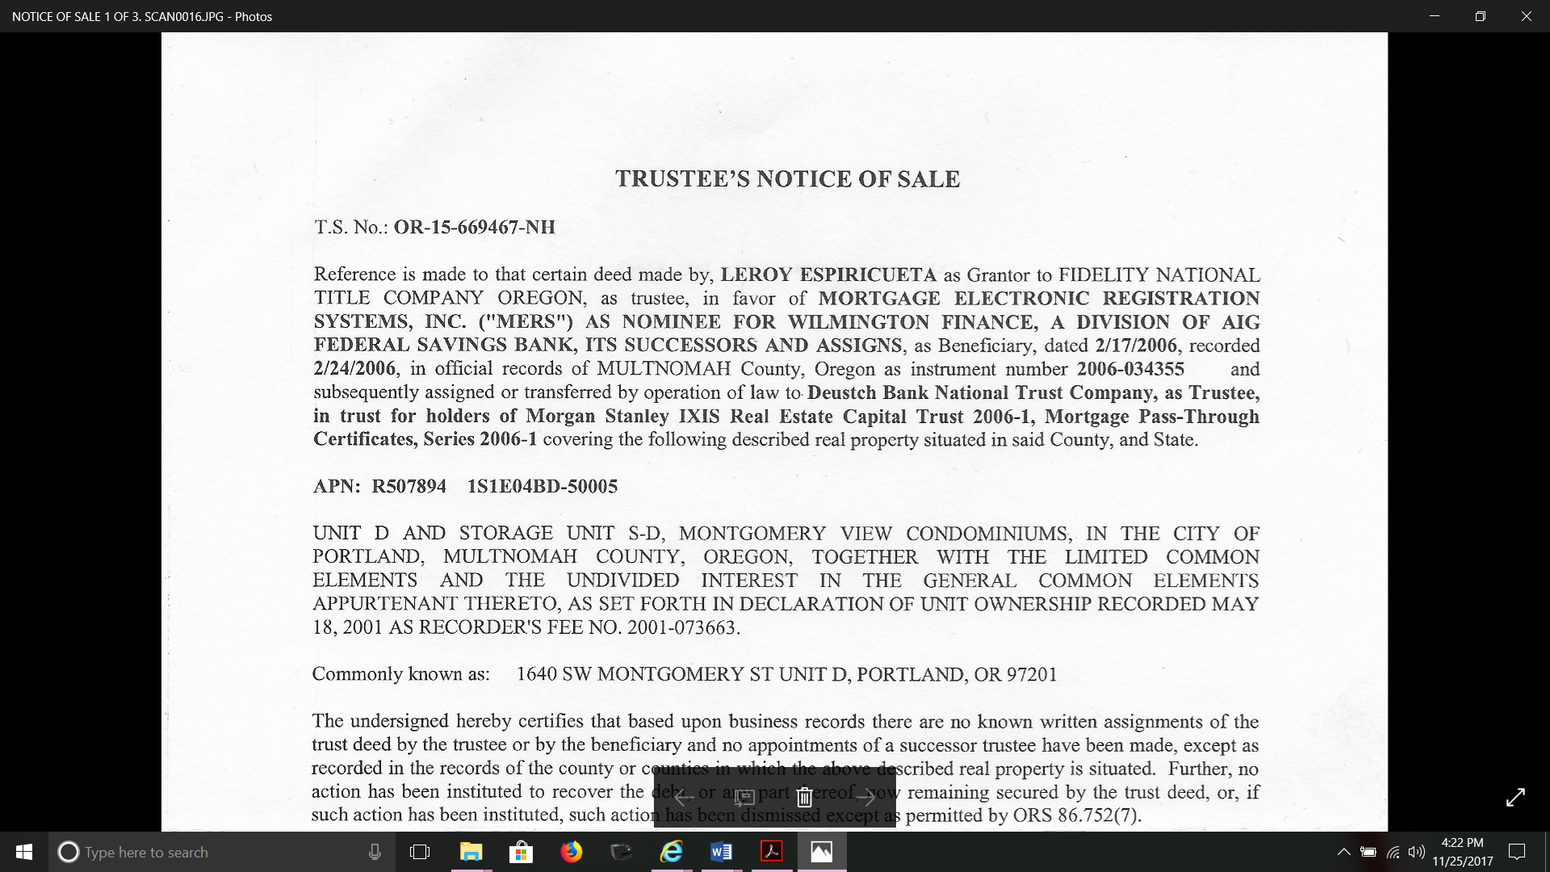

and,

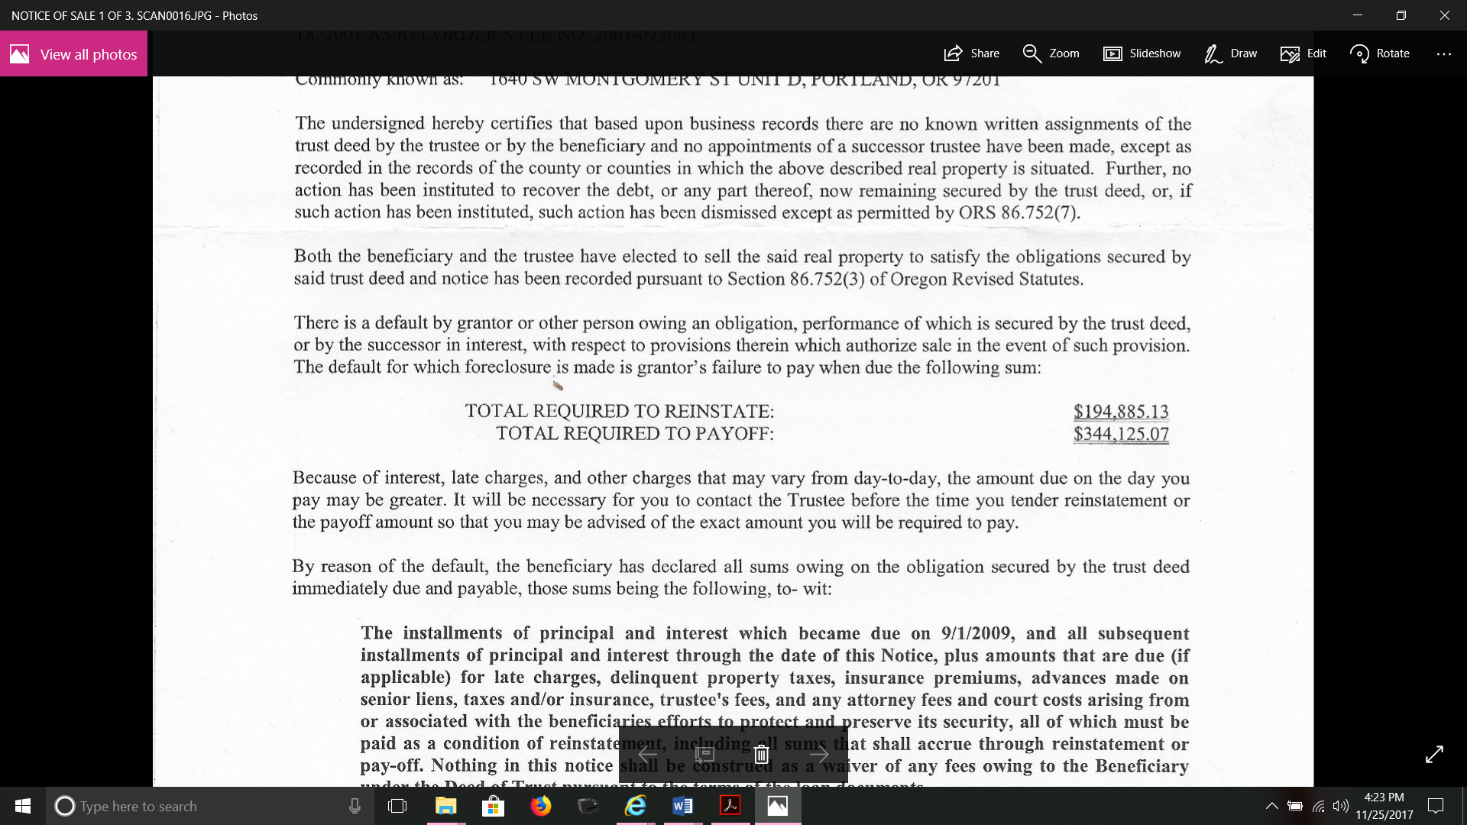

51. As Trustee, Defendant Quality Loan demonstrates uncertainty and fraud as to whether Plaintiff’s Deed of Trust was “subsequently assigned or transferred by operation of law to the Certificateholders of the 2006-1 Trust under the provisions of the PSA.

52. Quality Loan’s statement is further fraudulent in that it intentionally mistakes and misstates the history and laws of Our Great Nation. In real property transactions and transfers in the United States and the State of Oregon, the deed of conveyance is the “principal” and the “thing” that transfers all its incidents, including the right of possession and any easements, unless expressly exempted.

53. Legislative and Judicial philosophies have long held that the incident follows the principal and not the principal the incident and that the incident can never transfer the thing itself. In the early case of *Van Rensselaer v. Kearney,* 52 U.S. (11 How.) 297, 322 (1850), the Court held:

“The general principle is admitted that a grantor, conveying by deed of bargain and sale, by way of release or quitclaim of all his right and title to a tract of land, if made in good faith and without any fraudulent representations, is not responsible for the goodness of the title beyond the covenants in his deed. (Citations omitted.) A deed of this character purports to convey, and is understood to convey, nothing more than the interest or estate of which the grantor is seized or possessed at the time, and does not operate to pass or bind an interest not then in existence.”

54. In *Carpenter v. Longan*, 83 U.S. (16 Wall.) 271, 274 (1872), Mr. Justice Swayne reaffirmed the rule that an assignee takes the mortgage as he takes the note: “The note and mortgage are inseparable; the former as essential, the latter as an incident. An assignment of the note carries the mortgage with it, while an assignment of the latter alone is a nullity.” “All the authorities agree that the debt is the principal thing and the mortgage an accessory.”

55. Further fraud is exposed by Defendant Quality Loan in its statement that: “Both the beneficiary and the trustee have elected to sell the said property to satisfy the obligations secured by said trust deed….” Missing from this statement is the names of the “beneficiary” and the “trustee” who unlawfully conspired or agreed to sell Plaintiff’s real property which in turn makes it difficult for Plaintiff to determine the proper parties who must be sued to stop the foreclosure.

56. Further fraud is exposed by Defendant Quality Loan in its statement that: “There is a default by grantor or other person owing an obligation….” Defendant Quality Loan appears to lack clear knowledge of its role and obligations as a “trustee” to ascertain and execute correct nonjudicial foreclosure processes and procedures.

57. On March 4, 2010, the United States commenced a civil action against AIG Federal Savings Bank (“AIG FSB”) and Wilmington Finance, Inc. (WFI), Case No. 99-mc-09999, Federal District Court, District of Delaware.

58. The Complaint alleged that AIG FSB and Plaintiff’s original Lender, WFI, engaged in a pattern or practice of conduct in violation of the Fair Housing Act (FHA), 42 U.S.C. §§ 3601-3619, and the Equal Credit Opportunity Act (ECOA), 15 U.S.C. §§ 1691-169lf, by allowing their wholesale mortgage brokers to charge African-American borrowers higher direct broker fees for residential real estate-related loans than white borrowers.

59. The United States found, in support of its complaint, that from July 2003 to May 2006 “Black”/“African-American” borrowers nationwide were charged total broker fees 20 basis points higher as a percentage of the loan amount, on average, than the total broker fees charged to white borrowers for WFI and AIG FSB’s loans and that these disparities extended to at least 19 metropolitan areas (MSAs) in which AIG FSB and WFI made a substantial number of brokered-loans-to black-and white-borrowers in cities including Portland, Oregon.

60. Said the United States, “[i]n these MSAs black borrowers paid total broker fees ranging from 25 to 75 basis points higher, on average, than the total broker fees paid by white borrowers. All of these disparities are statistically significant.”

61. On March 19, 2010, fifteen days after commencing its action, the Federal District Court allowed the United States and AIG FSB and WFI to settle their dispute and further ordered Defendants AIG FSB and WFI to deposit in an interest-bearing escrow account the total sum of $6.1 million to pay damages to Plaintiff and other aggrieved persons who may have suffered due to the alleged violations of the Fair Housing and Equal Credit Opportunity Acts. WFI further informed the United States that it was winding up its business affected by the alleged fraudulent practices.

62. Plaintiff has never been contacted by AIG FSB and WFI with regards to their settlement with the Federal Government for their discrimination against Plaintiff and other Portland homeowners similarly situated.

63. On September 21, 2007, HSBC Holdings announced it was closing Decision One Mortgage, one of its U.S. subprime mortgage businesses, a move that triggered an $880 million accounting hit and $65 million in costs for the bank’s HSBC Finance division. According to the PSA, Decision One Mortgage Company, LLC was a “Responsible Party.”

64. The June 1, 2006 PSA also named First NLC Financial Services, LLC a “Responsible Party.” On March 4, 2008, the Washington Department of Financial Services (DFI) revoked First NLC’s license to conduct business. After ordering First NLC to pay numerous fines and fees, the State dissolved First NLC on June 2, 2008.

65. In July 2013, a court in West Palm Beach, Florida approved a $2.825 million settlement of claims brought by a bankruptcy trustee in state court against the former CEO, COO and Chief Restructuring Officer of First NLC Financial Services, LLC and affiliated companies, which had been one of the country’s leading subprime lenders before its bankruptcy in January 2008. First NLC’s top officers were also sued for breaches of fiduciary duties and gross negligence and for a “bizarre process” in which the purchaser, a company affiliated with a business that had taken a majority ownership position in First NLC months earlier, selected certain other companies to act as “bidders” for the loan portfolio, and used their “bids” to establish a supposed “market value” for the portfolio.

66. In May of 2014, the Center for Public Integrity (“Center”) completed an analysis of government data on nearly 7.2 million “high-interest” or subprime loans made from 2005 through 2007. The investigation found that the top 25 originators of high-interest loans, such as the one received by Plaintiff from WFI, accounted for nearly $1 trillion, or about 72% of such loans made during that period.[3] The Center found that U.S. and European investment banks invested enormous sums in subprime lending, while investment banks Lehman Brothers, Merrill Lynch, JPMorgan & Co., and Citigroup Inc. owned and financed subprime lenders. Others, like RBS Greenwich Capital Investments Corp. (part of the Royal Bank of Scotland), Swiss bank Credit Suisse First Boston, and Goldman Sachs & Co., were major financial backers of subprime lenders.

67. According to the Center, at least 21 of the top 25 subprime lenders were financed by banks that received Federal bailout money and that 20 of the top 25 subprime lenders have closed, stopped lending, or have been sold to avoid bankruptcy. Most were not banks and were not permitted to collect deposits. Eleven of the lenders on the list made payments to settle claims of widespread lending abuses. Four of those received Federal bank bailout funds, including American International Group Inc., parent of WFI, and Citigroup Inc.

68. Between 2000 and 2007, backers of subprime mortgage-backed securities underwrote $2.1 trillion worth of business. The top underwriters were Lehman Brothers; RBS Greenwich Capital Investments Corp.; Countrywide Securities Corp.; Morgan Stanley, Merrill Lynch, Bear Stearns, and Goldman Sachs.

69. When New Century filed for bankruptcy, it listed Goldman Sachs Mortgage Co. as one of the 50 largest unsecured creditors. Other New Century creditors included Bank of America, Morgan Stanley, Citigroup, Barclays, and Swiss bank UBS. New Century earlier reported to its shareholders that it had lines of credit totaling $14.1 billion from those five banks, plus Bear Stearns, Credit Suisse First Boston, Deutsche Bank, and IXIS Real Estate Capital, a French banking firm (since taken over by a company called Natixis) that frequently worked with Morgan Stanley.

70. On February 26, 2014, the Washington State Attorney General commenced a consumer complaint against Defendant Quality Loan for failure to maintain a physical office, among other violations, committee by a Trustee, to wit:

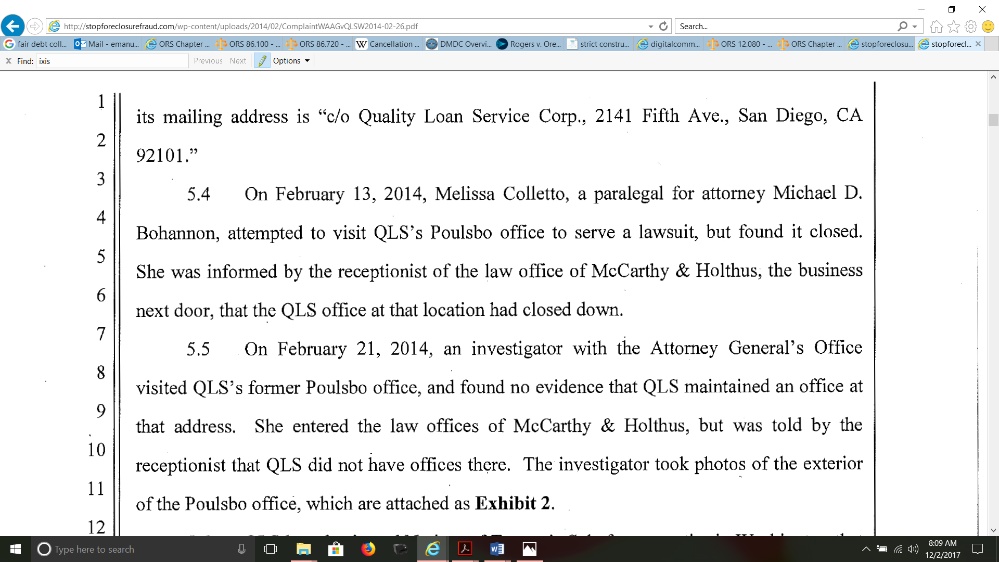

71. At the time the lawsuit was commenced by Washington, Defendant Quality Loan was owned, operated and managed by at least two law partners associated with Defendant McCarthy Holthus law firm, attorneys Thomas Holthus and Kevin McCarthy, to wit:

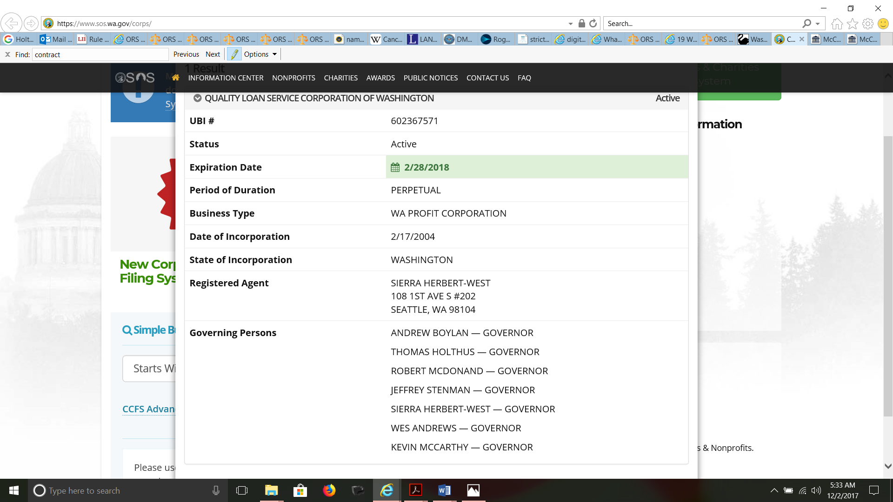

72. Stated differently, Defendant McCarthy Holthus law firm fraudulently and intentionally misled the Attorney General of the State of Washington as to its true relationship with Defendant Quality Loan to such an extent to require that the corporate of both Defendants be pierced.

73. In a disclosure request dated August 22, 2017, Plaintiff requested Select Portfolio provide a copy of Plaintiff’s original Note and any endorsements made thereon, including the name of the custodian and the location where the original Note could be inspected and any information to support the sale, transfer, assignment or endorsement of Plaintiff’s original Note/Loan/Debt to the Certificateholders of the 2006-1 Trust or any other person or entity.

74. In response to Plaintiff’s correspondence, Select Portfolio failed to provide any information responsive to Plaintiff’s request for disclosure.

75. On September 11, 2017, the United States commenced a civil action, Case No. CV 17-5305, U.S. District Court Eastern District of New York, against Paul Mangione (“Mangione”), head of Deutsche Bank AG’s (“Deutsche Bank”) subprime whole loan trading desk, on account of his participation in Deutsche Bank’s fraudulent and illegal scheme affecting financial institutions and other investors in connection with two residential mortgage-backed securities where Mangione and Deutsche Bank systematically and intentionally misrepresented key characteristics of the mortgage loans securitized by Deutsche Bank despite knowing the representations were false and that the two securities had an escalating likelihood of widespread defaults. Further, Deutsche Bank securitized hundreds of thousands of additional loans made to borrowers that fell in other categories.

76. Previously in May 2006, Deutsche Bank purchased Chapel Funding, LLC (“Chapel”) for Chapel to be “an origination engine to feed the different DB trading desks” and to perform quality control checks which revealed systemic deficiencies not only in the loans, but in Chapel’s origination processes themselves. By the time Deutsche Bank issued the securities, the quality control checks performed by Deutsche Bank reflected that nearly 50% of the loans it had reviewed had significant defects, including rampant guideline violations, borrower fraud, inflated appraisals and loans made to borrowers that likely did not have the ability to repay their loan.

77. At Mangione’s direction and with his approval, the defective loans were securitized anyway, which were “owned” by Deutsche Bank when purchasing Chapel. Rather than accept the loss certain to be generated by its subsidiary’s abandonment of responsible underwriting practices, or disclose to investors the defects, Deutsche Bank and Mangione surreptitiously securitized the defective loans, thereby knowingly passing the loss on to their investors. Mangione, according to the Government’s Complaint, “personally selected the loans that went into [the two Deutsche Bank securities].”

78. The Government further alleged that “Mangione was aware not only of the issues with the Chapel loans that Deutsche Bank securitized in HE4 and HE5, but he was also aware of substantial issues with Chapel’s origination processes and its management, including management’s fraud designed to cover up their abandonment of any semblance of underwriting standards in an effort to originate as many loans as possible, i.e., “drive volume.’”

79. On November 27, 2017, Plaintiff served Defendant Quality Loan, the law firm of McCarthy & Holthus, LLP and all Parties to the June 1, 2006 PSA with an advance copy of this lawsuit and further requested the addressees reconvey Plaintiff’s deed of trust and the Original Note, to wit:

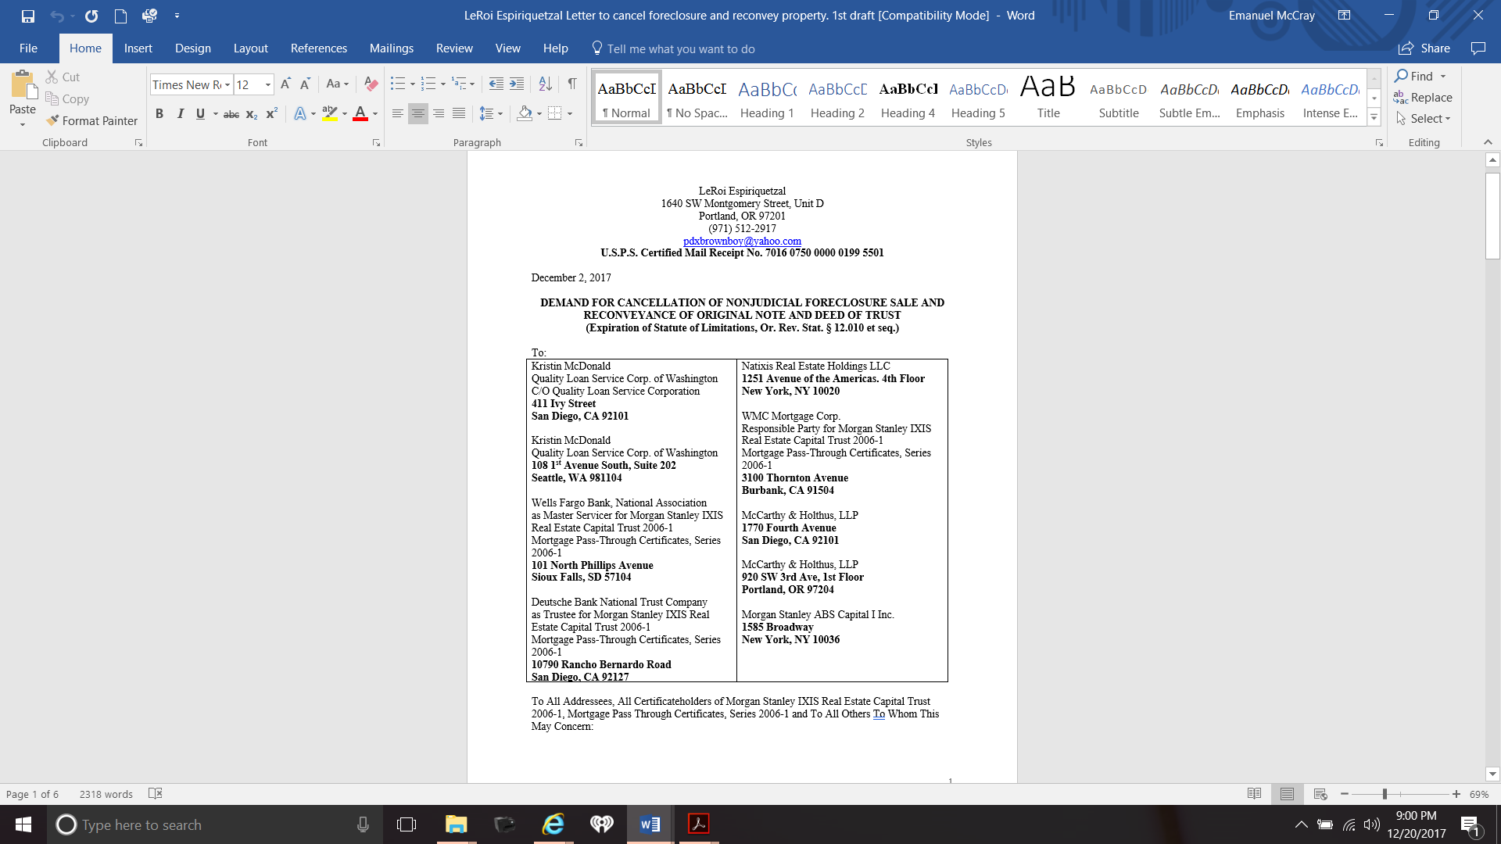

80. The U.S. Postal Service confirmed that on December 8, 2017 at 11:37a.m., Defendant law firm McCarthy & Holthus accepted delivery of Plaintiff’s demand mailed under U.S.P.S. Certified Mail Receipt No. 7016 0750 0000 0199 5501, <https://tools.usps.com/go/TrackConfirmAction?tRef=fullpage&tLc=2&text28777=&tLabels=70160750000001995501%2C>.

81. None of the other letters mailed to the Parties to the PSA have been returned by the U.S. Postal Service. As of the date of this action, none of the above-named addressees have responded to Plaintiff’s correspondence in direct violation of Pub. Law 111-22 and Oregon’s nonjudicial foreclosure and unlawful detainer laws.

82. Defendant Quality Loan and the other addressees were also advised that the “nominee doctrine” was not available to them because the statute of limitations had run on the debt and that MERS could not serve as “beneficiary” of Plaintiff’s deed of trust or “nominee” for Defendant Wilmington Finance to initiate nonjudicial foreclosure because the appointments of MERS and the Trustee ceased on June 1, 2006 when the Certificateholders of the 2006-1 Trust issued their PSA, which established the legal and contractual obligations among the parties to the PSA. A copy of the PSA is available on the website of the Securities and Exchange Commission at:

(1) Morgan Stanley IXIS Real Estate Capital Trust 2006-1 (Filer) CIK: 0001365336: <https://www.sec.gov/Archives/edgar/data/1365336/000091412106002439/0000914121-06-002439-index.htm>; and

(2) Morgan Stanley IXIS Real Estate Capital Trust 2006-1, Exhibit 4, Pooling and Servicing Agreement: <https://www.sec.gov/Archives/edgar/data/1365336/000091412106002439/ms909983-ex4.txt>.

83. In *Fourth Investments, LP v. United States,* 720 F.3d 1058 (9th Cir. 2013), the Court of Appeals affirmed the District Court in favor of the government in a quiet title action in which the plaintiff partnerships sought to remove a tax lien on properties to which the partnerships held title. The Court ruled that the relevant state law controlled the determination of whether title to the property was held as a nominee and that under the “nominee doctrine,” the partnerships held the properties as nominees of the taxpayers under California law and were liable for the lien taxes.

84. Defendants Quality Loan and McCarthy Holthus, in addition to failing to respond to Plaintiff’s correspondence, have also not identified any Party to the PSA authorizing them to act as “Trustee” and commence the nonjudicial foreclosure sale of Plaintiff’s interest on December 28, 2017.

85. In addition to failing to respond to Plaintiff’s correspondence, no Party to the PSA has contacted Plaintiff to provide evidence or proof to support ownership or possession of Plaintiff’s original Note and its endorsements or evidence or proof to support an agency/contract relationship with Defendants Quality Loan, McCarthy Holthus, Realty Trust and Don McCredie.

86. If Plaintiff’s original Note was sold/assigned/transferred to the Certificateholders, the PSA further provides that Plaintiff’s original Note, issued in February 2006, was subject to a December 1, 2005 “Agreement” between “AIG Federal Savings Bank, a federally chartered savings bank” and the Certificateholders of the 2006-1 Trust as follows:

(1) AIG Agreements: The AIG Purchase Agreement and the AIG Assignment

Agreement, copies of which are attached hereto as Exhibit S;

(2) AIG Assignment Agreement: The Assignment and Recognition Agreement,

dated as of the Closing Date, among MSMC, the Depositor and AIG;

(3) AIG Mortgage Loans: The Mortgage Loans purchased by MSMC pursuant

to the AIG Purchase Agreement for which AIG is identified as Originator

on the Mortgage Loan Schedule;

(4) AIG Purchase Agreement: The Third Amended and Restated Mortgage

Loan Purchase and Warranties Agreement, dated as of December 1, 2005,

between AIG and MSMC; and

(5) Exhibit S: AIG Agreements.

87. Section 3.01 of Article III of the PSA for the 2006-1 Trust specifically provides that the Trustee for the 2006-1 Trust Subject shall furnish a power of attorney to any Servicer or any Subservicer to carry out its servicing and administrative duties under the PSA as set forth “in the form of Exhibit OO hereto….”

88. Defendant Quality Loan has refused to provide its authority to make the Certificateholders of the 2006-1 Trust liable for its actions in commencing the unlawful nonjudicial foreclosure of Plaintiff’s real property.

89. Section 3.01 of Article III of the PSA for the 2006-1 Trust further provides that:

“The Trustee shall not be liable for the actions of any Servicer or any Subservicers under such powers of attorney. Notwithstanding anything contained herein to the contrary, no Servicer or Subservicer shall without the Trustee’s consent: (i) initiate any action, suit or proceeding solely under the Trustee’s name without indicating such Servicer’s or Subservicer’s, as applicable, representative capacity, or (ii) take any action with the intent to, or which actually does cause, the Trustee to be registered to do business in any state.”

90. On December 28, 2017, the company that appeared to be hosting Defendant Quality Loan’s trustee sale information indicated, without further description, that Plaintiff’s home was “Sold back beneficiary for $265,000, to wit:

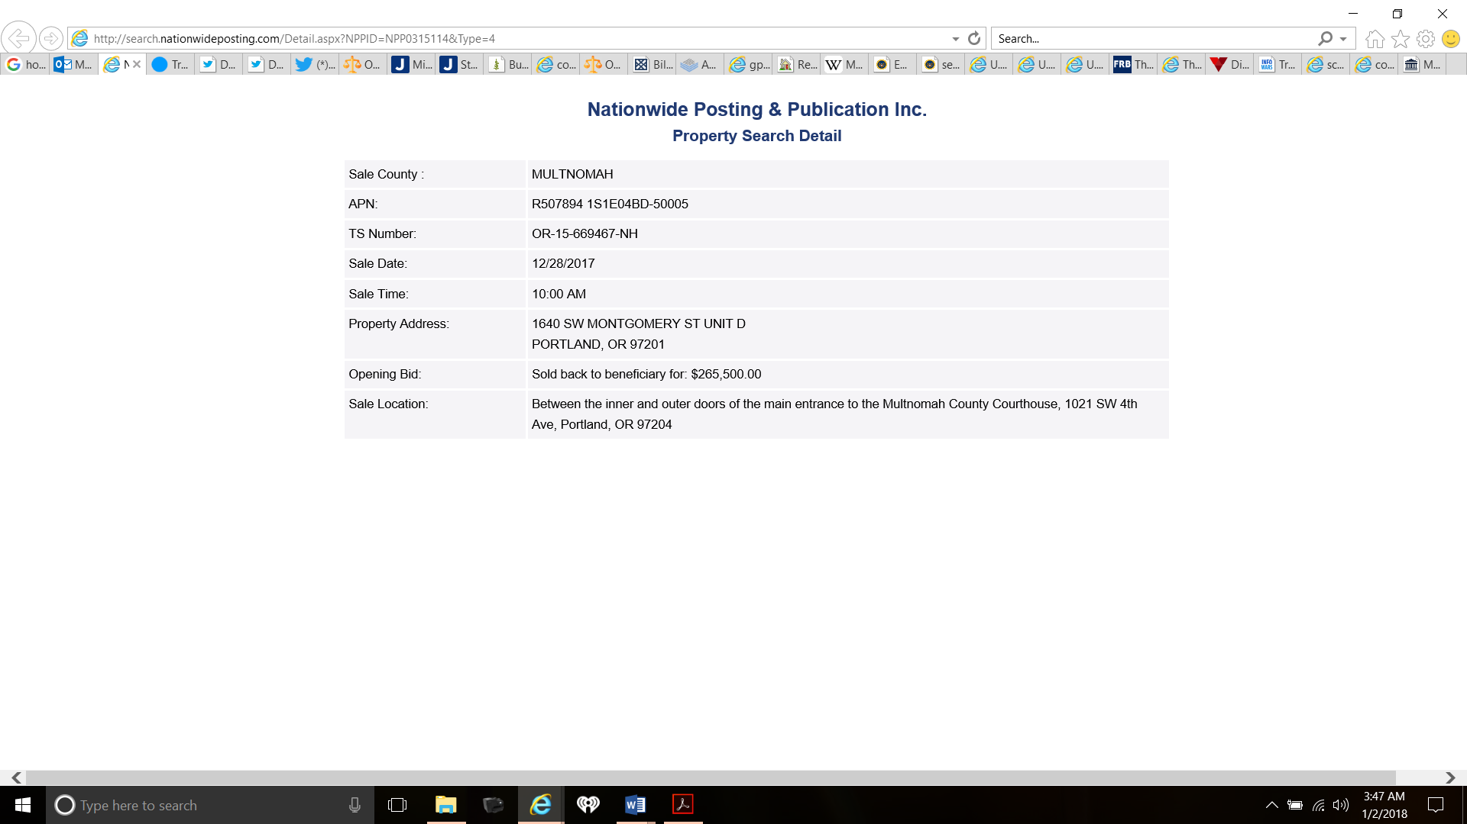

91. According to the California Secretary of State, the State had on file information indicating that Nationwide Posting & Publication Inc. had “dissolved” as of December 20, 2013, to wit:

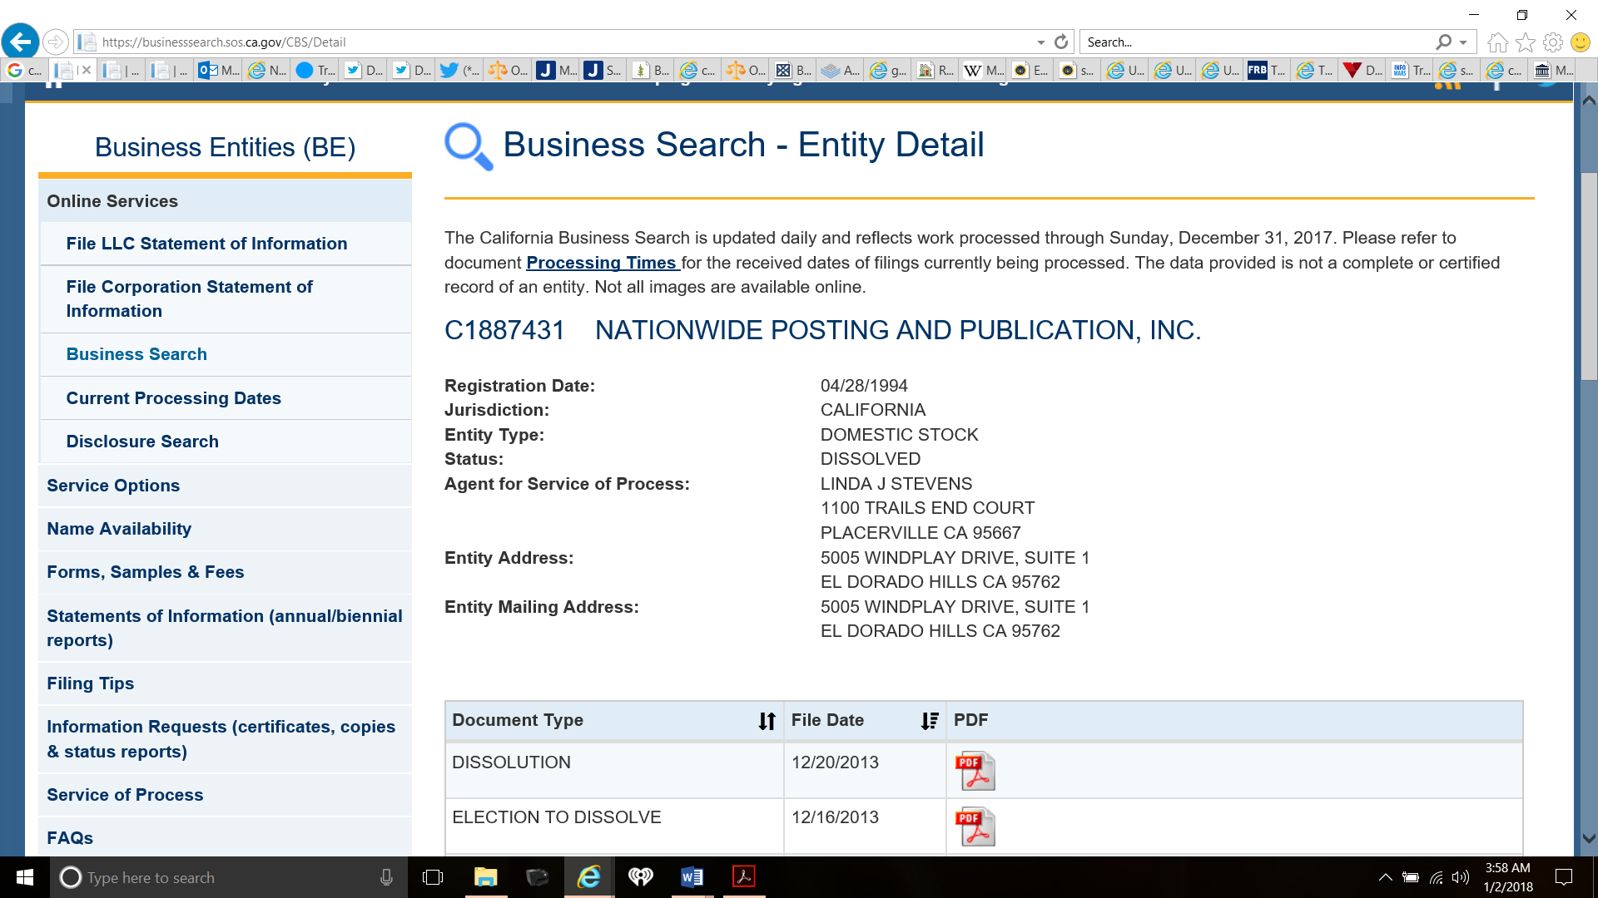

///

///

///

///

///

///

///

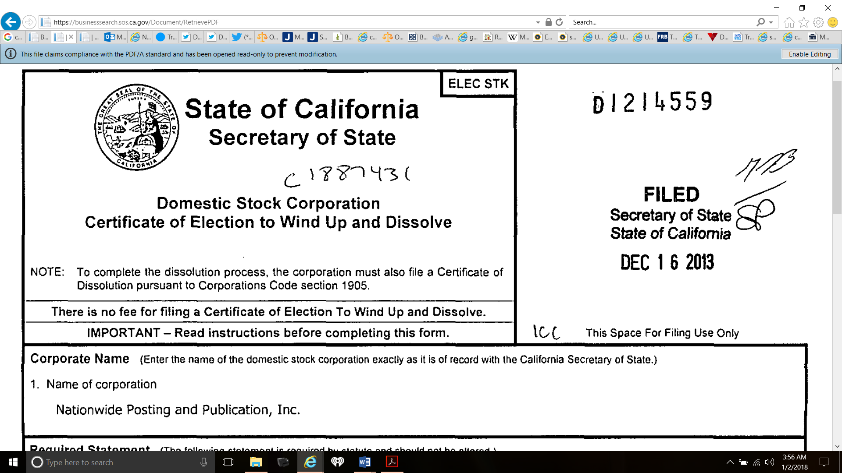

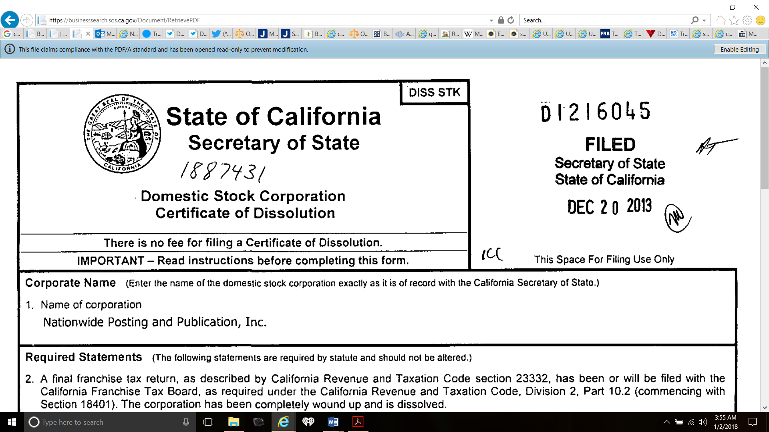

See also Plaintiff’s Exhibits 10 and 11 attached hereto.

92. According to the “WHOIS Lookup” search engine operated by Internet Corporation for Assigned Names and Numbers (“ICANN”), the website currently operating under the dissolved name of “Nationwide Posting & Publication Inc.,” <http://nationwideposting.com/>, is owned and managed by Defendant FATCO Holdings, LLC, to wit:

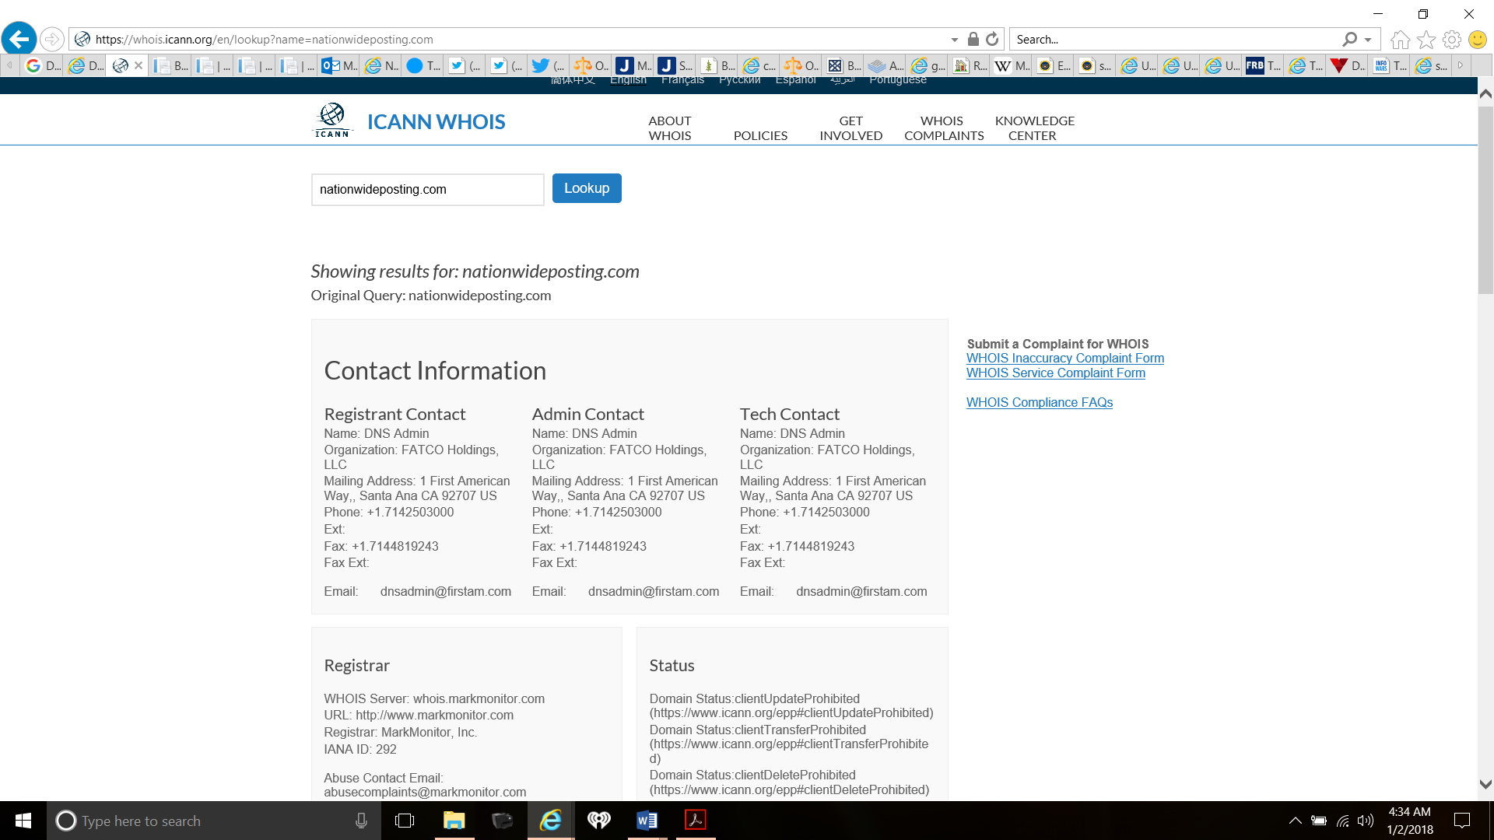

93. By claiming to operate a website in the dissolved name of “Nationwide Posting & Publication Inc.,” First American Financial Corporation is deceiving and confusing the public. First American Financial Corporation further claims in its disclaimer that it assumes “no responsibility for errors or omissions”, to wit:

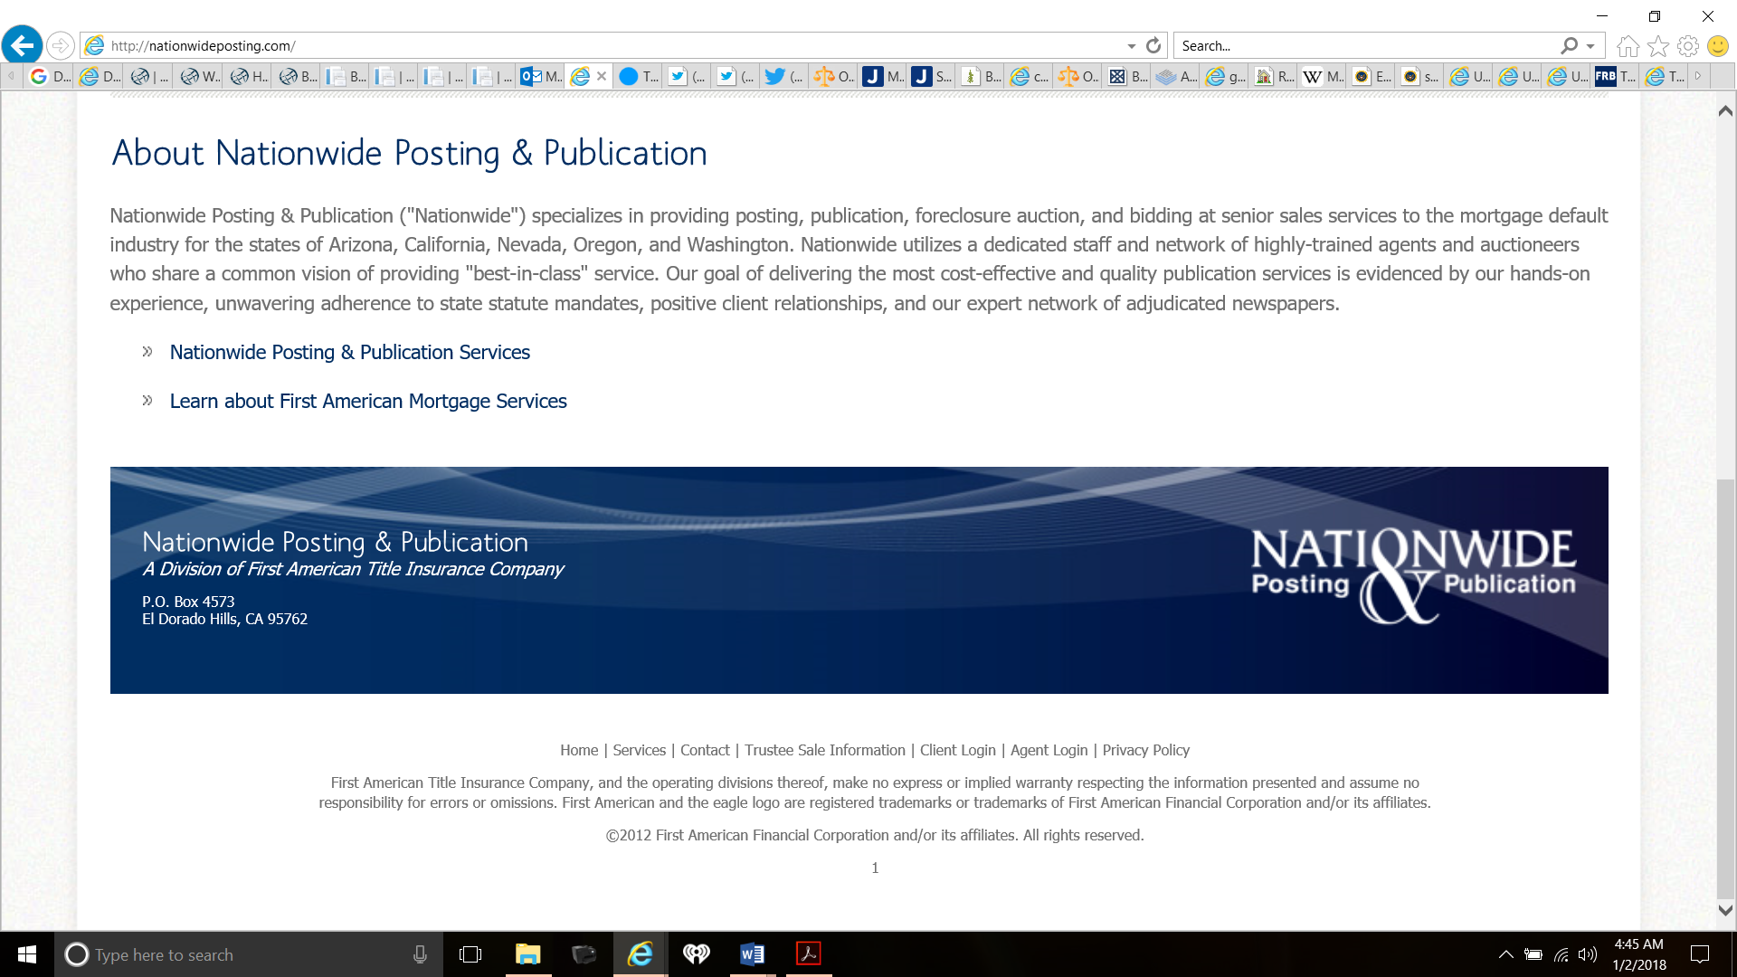

94. In the event it is discovered that the Certificateholders of the 2006-1 Trust and or any of the Parties to the PSA for the 2006-1 Trust and the Parties to the 2006 PSA did not authorize the alleged wrongful actions of Defendants Quality Loan, FATCO Holdings, McCarthy Holthus, Realty Trust and Don McCredie, Plaintiff will seek leave of the Court to amend this action to conform to such discovery and evidence pursuant to Oregon Rules of Civil Procedure (ORCP); Amendments Fourth, Fifth and Fourteenth and 42 U.S. Code § 1983.

95. Defendants Quality Loan, FATCO Holdings, McCarthy Holthus, Realty Trust and Don McCredie Defendant Quality Loan refused to bring their alleged unlawful acts into compliance with Pub. Law 111-22 which resulted in their racketeering conspiracy/agreement associated with the nonjudicial foreclosure of Plaintiff’s real property on December 28, 2017. As a result, Plaintiff is entitled to substantial consequential treble and punitive damages.

96. Because Defendant Quality Loan unlawfully sold Plaintiff’s real property, Plaintiff will refuse to voluntarily relinquish possession of his real property to the so-called “beneficiary” at the nonjudicial foreclosure sale. This resistance will require the so-called “beneficiary” to seek “unlawful detainer” enforcement assistance from the State of Oregon and the Sheriff of Multnomah County, which is the normal procedure followed by purchasers at a nonjudicial foreclosure sale.

97. When this unlawful detainer action is commenced, the so-called “beneficiary”/purchaser and the State of Oregon will become parties to an undeniable public-private partnership created by the operation of Chapter 86 of Title 9 and Chapter 105 of Title 10, which creates privity, *Stacy v. Thrasher,* 47 U.S. 6 How. 44, 60 (1848), and brings them within the rule of *Shelley v. Kraemer,* 334 U.S. 1, 13-14 (1948); *Sniadach v. Family Fin. Corp.,* 395 U.S. 337, 338-39 (1969); *Fuentes v. Shevin,* 407 U.S. 67, 70-71 (1972); *North Georgia Finishing, Incorporated v. Di-Chem, Inc.*, 419 U.S. 601 (1975); *Lugar v. Edmondson Oil Company,* 467 U.S. 922, 934, 940-42 (1980); and *Edmondson v. Leesville Concrete Company*, 500 U.S. 614 (1991), all of which hold that a private party becomes a state actor if he or she uses a state procedure requiring state intervention, ratification or enforcement of the private conduct, such as the forceful eviction of a homeowner.

98. In the event an unlawful detainer action is commenced, Plaintiff will seek leave of the Court to amend this complaint to state causes of actions against Defendants Reese and Brown pursuant to Amendments Fourth, Fifth and Fourteenth and 42 U.S. Code § 1983.

99. Due to the actions, inactions and omissions of each Defendant, as set forth *supra,* Plaintiff is suffering a deprivation of human dignity and a denial of the Federal cash- and credit-using system without constitutional due process of law and in violation of Pub. Law 111-22.

**VI. CAUSES OF ACTION**

**First Cause of Action: Violation and Conspiracy to violate Pub. Law 111-22 and the Fair Debt Collection Practices Act, 15 USC §§ 1692e(2)(A), e(4), e(5), e(6) and e(10); 1692f(1) and f(6)(A) and (C); 1692g(b) and 1692j.**

100. The allegations set forth above in paragraphs 1 through 99 of this Complaint are realleged as if fully set forth in this paragraph.

101. Plaintiff remains ignorant as to the true recipient of the initial payments made on the Note in 2006 and Plaintiff has been unable to locate any person or entity who was willing to claim to be the owner or holder of Plaintiff’s original Note.

102. Nearly every Party to the June 1, 2006 PSA established for Defendant Certificateholders of the 20016-1 Trust has been fined and or penalized by the United States and several State Governments, including the State of Oregon.

103. Under Oregon laws, the statute of limitations for an action on Plaintiff’s Note is governed by Or. Rev. Stat. § 12.010 et seq. and Chapter 71 of Oregon’s Uniform Commercial Code, which provides that a loan of money payable on demand creates a present debt and that the statute of limitations begins to run against the lender from the date of the loan.

104. Title 26 U.S.C. § 61(a)(12) further provides that a Lender has a duty to cancel any debts that are no longer “legally enforceable,” so as to cause a “freeing of assets.”; *Commissioner v. Glenshaw Glass Co*, 348 U.S. 426 (1955); *U.S. v. Kirby Lumber Co.,* 284 U.S. 1 (1931). See also, *Zarin v. Commissioner,* 916 F.2d 110 (3rd Cir. 1990), explaining that the “Disputed Debt Doctrine” can also apply if the Note is no longer legally enforceable.

105. Further, when enacting Pub. Law 111-22, Congress intended to “prevent” foreclosures using a comprehensive scheme set forth in Pub. Law 111-22.

106. Additionally, Congress expressly joined Division B of Pub. Law 111-22, 42 U.S.C. §§11301 *et seq.,* Plaintiff’s Exhibit 7 at 32-72, with Chapter 130, 42 U.S.C. §§12701 *et seq.* (national affordable housing). Congress’ “national housing policy” is expressed in 42 U.S.C. §12702, to wit:

§12702. Objective of national housing policy

The objective of national housing policy shall be to reaffirm the long-established national commitment to decent, safe, and sanitary housing for every American by strengthening a nationwide partnership of public and private institutions able—

(1) to ensure that every resident of the United States has access to decent shelter or assistance in avoiding homelessness;

(2) to increase the Nation’s supply of decent housing that is affordable to low-income and moderate-income families and accessible to job opportunities;

(3) to improve housing opportunities for all residents of the United States, particularly members of disadvantaged minorities, on a nondiscriminatory basis;

(4) to help make neighborhoods safe and livable;

(5) to expand opportunities for homeownership;

(6) to provide every American community with a reliable, readily available supply of mortgage finance at the lowest possible interest rates; and

(7) to encourage tenant empowerment and reduce generational poverty in federally assisted and public housing by improving the means by which self-sufficiency may be achieved.

107. In Oregon, the postulate that “ignorance of the law is no excuse” is codified at ORS 161.115(4). *State v. Van Norsdall,* 127 Or. App. 300, 873 P.2d 345 (1994) and *Mitchell v. Chernecki*, 286 Or. 285, 593 P.2d 1163 (Dept. 1, 1979), citing, John Selden, Table Talk, “Law”:

“Ignorance of the law excuses no man; not that all men know the law, but because ‘tis an excuse every man will plead, and no man can tell how to confute him.”

108. Defendants Quality Loan, McCarthy Holtus, Certificateholders of the 2006-1 Trust, Morgan Stanley IXIS Real Estate Capital Trust 2006-1, Morgan Stanley Abs Capital I Inc., Wells Fargo Bank, National Association, Deutsche Bank National Trust Company and the other parties to the PSA for the 2006-1 Trust have each refused to respond to Plaintiff’s communications. This conduct alone is wholly inconsistent with Pub. Law 111-22 and 42 U.S.C. §§12701 *et seq.*

109. Plaintiff was entitled to receive proof of their authority to commence a nonjudicial foreclosure of Plaintiff’s real property more than 11 years after the original Note was executed. Instead, Plaintiff received absolutely nothing in return for his attempts to resolve this matter in accordance with Federal and Oregon laws.

110. It is malicious, despicable, strange, inconceivable, unusual and makes no logical or legal sense that the agent of a Trustee or beneficiary claiming to have lawful authority to commence a nonjudicial foreclosure would fail to respond to communications from a homeowner after the Trustee itself gave notice to the homeowner of the planned nonjudicial foreclosure proceedings.

111. It is further an unfair and unlawful business practice for a Trustee and a so-called Beneficiary to fail to communicate with a homeowner seeking reconveyance of the original Note and Deed of Trust after the debt is no longer due and owed.

112. When enacting the FDCA, Congress found there to be abundant evidence of the use of abusive, deceptive, and unfair debt collection practices by many debt collectors that contributed to “the number of personal bankruptcies, to marital instability, to the loss of jobs, and to invasions of individual privacy.”

113. It was the purpose of the FDCPA “to eliminate abusive debt collection practices by debt collectors, to insure that those debt collectors who refrain from using abusive debt collection practices are not competitively disadvantaged, and to promote consistent State action to protect consumers against debt collection abuses.”

114. Being a remedial statute, the FDCPA is to be construed liberally in favor of consumer.

115. The FDCPA is designed to protect Plaintiff from Defendant’s unfair practices regardless of whether a valid debt exists or not.

116. The fact that nonjudicial foreclosure may be an authorized method of foreclosure in the State of Oregon does not excuse Defendant’s conduct in not complying with the FDCPA, Pub. Law 111-22 and 42 U.S.C. §§12701 *et seq.*

117. Defendants Quality Loan, McCarthy Holtus, Certificateholders of the 2006-1 Trust, Morgan Stanley IXIS Real Estate Capital Trust 2006-1, Morgan Stanley Abs Capital I Inc., Wells Fargo Bank, National Association, Deutsche Bank National Trust Company, Realty Trust Group, Inc., Don McCredie and FATCO Holdings, LLCare jointly and severally liable to Plaintiff for his damages and the costs of this action, together with a reasonable attorney’s fee as determined by the court pursuant to 15 U.S.C. § 1692k.

**Second Cause of Action: Violation of and Racketeering Conspiracy To Violate Pub. Law 111-222 and Or. Rev. Stat. § 86.720.**

118. The allegations set forth above in paragraphs 1 through 117 of this Complaint are realleged as if fully set forth in this paragraph.

119. Under the Oregon Trust Deed Act, Or. Rev. Stat. § 86.705 et seq., when an entity is neither the trustee nor the beneficiary, it holds no interest at all in the lien conveyed by the trust deed. *Brandrup v. ReconTrust Co., N.A.,* 353 Ore. 668, 303 P.3d 301, 2013 Ore. LEXIS 414 (Or. 2013).

120. Or. Rev. Stat. § 86.720(1) provides in pertinent part that:

“Within 30 days after performance of the obligation secured by the trust deed, the beneficiary shall deliver a written request to the trustee to reconvey the estate of real property described in the trust deed to the grantor. Within 30 days after the beneficiary delivers the written request to reconvey to the trustee, the trustee shall reconvey the estate of real property described in the trust deed to the grantor. In the event the obligation is performed and the beneficiary refuses to request reconveyance or the trustee refuses to reconvey the property, the beneficiary or trustee so refusing shall be liable as provided by ORS 86.140 (Liability of mortgagee for failure to discharge mortgage) in the case of refusal to execute a discharge or satisfaction of a mortgage on real property.”

121. Defendants Quality Loan, McCarthy Holtus, Certificateholders of the 2006-1 Trust, Morgan Stanley IXIS Real Estate Capital Trust 2006-1, Morgan Stanley Abs Capital I Inc., Wells Fargo Bank, National Association, Deutsche Bank National Trust Company and the other parties to the PSA for the 2006-1 Trust have not only failed to comply with Or. Rev. Stat. § 86.720(1) but have further refused to communicate in any manner or form with Plaintiff.

122. Defendants Quality Loan, McCarthy Holtus, Certificateholders of the 2006-1 Trust, Morgan Stanley IXIS Real Estate Capital Trust 2006-1, Morgan Stanley Abs Capital I Inc., Wells Fargo Bank, National Association, Deutsche Bank National Trust Company, Realty Trust Group, Inc., Don McCredie and FATCO Holdings, LLCare jointly and severally liable to Plaintiff pursuant to a civil conspiracy and Or. Rev. Stat. § 86.140, which provides in relevant part that:

“If any mortgagee or the personal representative or assignee of the mortgagee, after full performance of the condition of the mortgage before or after a breach thereof, shall, within 30 days after being thereto requested, and after tender of reasonable charges, fail to discharge the same, or to execute and acknowledge a certificate of discharge or release thereof, that person shall be liable to the mortgagor, or the heirs or assigns of the mortgagor, in the sum of $500 damages and also for all actual damages occasioned by such failure, to be recovered in an action at law.”

**Third Cause of Action: Wrongful Foreclosure.**

123. The allegations set forth above in paragraphs 1 through 122 of this Complaint are realleged as if fully set forth in this paragraph.

124. Defendant FATCO Holdings, LLC indicated on its website that Plaintiff’s property was “Sold back beneficiary for $265,000.” See paragraph 90 *supra.* This statement is misleading because Plaintiff’s property was never purchased from the unidentified “beneficiary.”

125. Defendant Quality Loan indicated in its “Trustee’s Notice of Sale,” Plaintiff’s Exhibit 4 at 1, that it was unsure whether Plaintiff’s original Note was “subsequently assigned or transferred by operation of law,” to with:

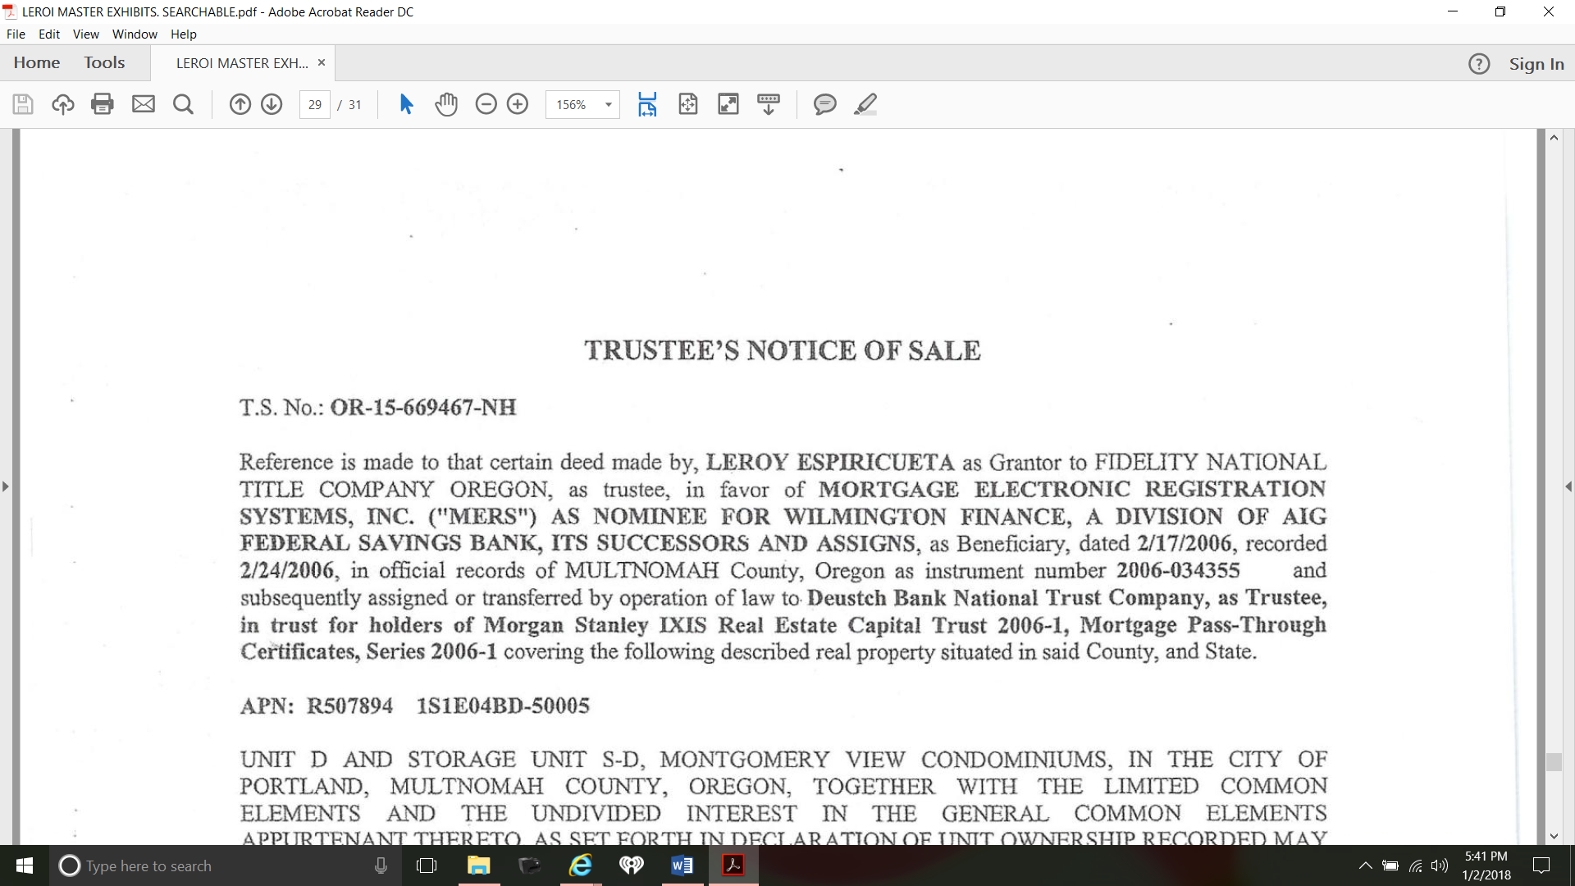

126. Plaintiff’s original Deed of Trust indicated that “**MERS is the beneficiary under this** **Security Instrument”,** to wit:

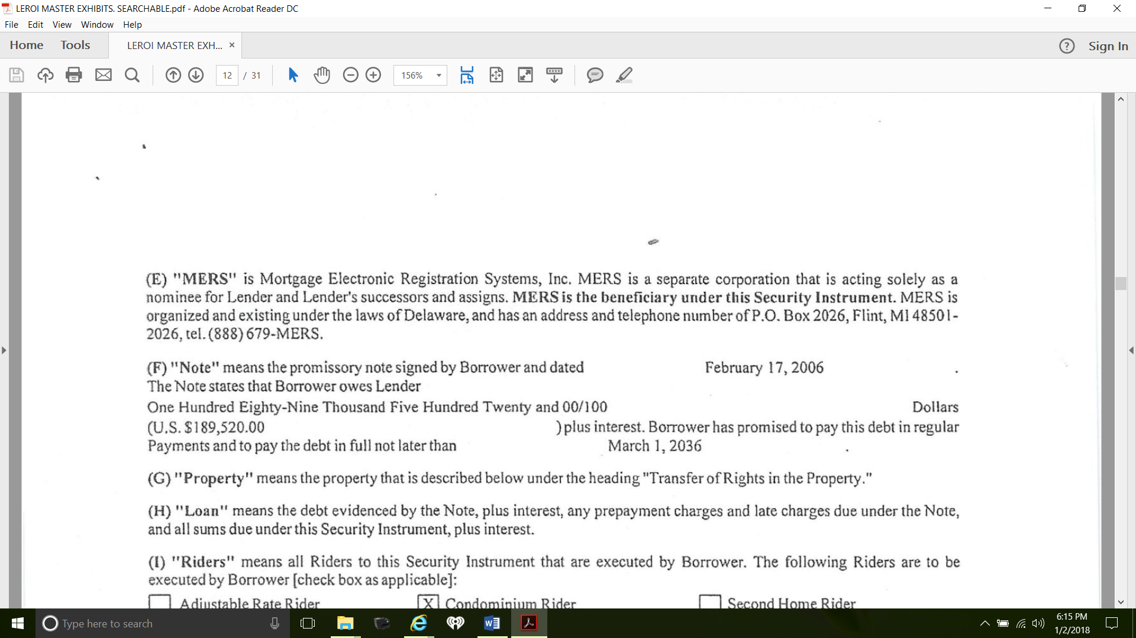

127. These “beneficiary” claims are confusing and deceptive and tends to mislead the public as to the real identity of the so-called “beneficiary”.

128. As alleged *supra*, no debt was due and the Note and Deed of Trust were unenforceable as a result. Further, Congress enacted laws which sought to “prevent” foreclosure.

129. Defendants Quality Loan, McCarthy Holtus, Certificateholders of the 2006-1 Trust, Morgan Stanley IXIS Real Estate Capital Trust 2006-1, Morgan Stanley Abs Capital I Inc., Wells Fargo Bank, National Association, Deutsche Bank National Trust Company and the other parties to the PSA for the 2006-1 Trust have refused to respond to Plaintiff’s December 2017 communications.

130. Defendants Quality Loan, McCarthy Holtus, Certificateholders of the 2006-1 Trust, Morgan Stanley IXIS Real Estate Capital Trust 2006-1, Morgan Stanley Abs Capital I Inc., Wells Fargo Bank, National Association, Deutsche Bank National Trust Company, Realty Trust Group, Inc., Don McCredie and FATCO Holdings, LLCare jointly and severally liable to Plaintiff in damages for the wrongful foreclosure sale conducted on December 28, 2017.

**VII. PRAYER FOR RELIEF**

*WHEREFORE*, having set forth the basis for this action, Plaintiff prays for the following relief:

(1) Court Order declaring the nonjudicial foreclosure, wrongful, invalid and void pursuant to Pub. Law 111-22; 42 U.S.C. §§12701 *et seq.; Niday v. GMAC Mortgage, LLC,* 353 Or. 648, 302 P3d 444 (2013); and *Brandrup v. ReconTrust Co.,* 353 Or 668, 303 P3d 301 (2013);

(2) Court Order directing removal of any derogatory mark of “Foreclosure” from Plaintiff’s Credit files pursuant to Pub. Law 111-22; 42 U.S.C. §§12701 *et seq.;* Fair Debt Collection Practices Act, 15 U.S.C. §§ 1692-1692p and the Fair Credit Reporting Act, 15 U.S.C. §§ 1681 et seq.;

(3) Court Order directing issuance of IRS Form 1099-C, Cancellation of Debt pursuant to Pub. Law 111-22; Title 26 U.S.C. § 61(a)(12); *Commissioner v. Glenshaw Glass Co*, 348 U.S. 426 (1955); *U.S. v. Kirby Lumber Co.,* 284 U.S. 1 (1931) and *Zarin v. Commissioner,* 916 F.2d 110 (3rd Cir. 1990);

(4) Court Order directing reconveyance of the Original Note and Deed of Trust within 30 days pursuant to Pub. Law 111-22; 42 U.S.C. §§12701 *et seq.;* Or. Rev. Stat. §§ 86.720 and 86.100; *Niday v. GMAC Mortgage, LLC,* 353 Or. 648, 302 P3d 444 (2013); *Brandrup v. ReconTrust Co.,* 353 Or 668, 303 P3d 301 (2013); 23 WLR 37, 55 (1987); 67 OLR 306 (1988); and 69 OLR 851 (1990);

(5) Permanent injunction against all Defendants and any other entity or person who in the future claim to be the owner or holder of Plaintiff’s original Note; and

(6) Judgment against Defendants Quality Loan, McCarthy Holtus, Certificateholders of the 2006-1 Trust, Morgan Stanley IXIS Real Estate Capital Trust 2006-1, Morgan Stanley Abs Capital I Inc., Wells Fargo Bank, National Association, Deutsche Bank National Trust Company, Realty Trust Group, Inc., Don McCredie and FATCO Holdings, LLC for appropriate civil penalties together with pre-and post-judgment interest and all allowable costs and attorneys’ fees, and for any other relief that the Court deems just and proper.

(7) Court Order declaring that the U.S. Constitution, Pub. Law 111-22 and 42 U.S.C. §§12701 *et seq.* imposed an affirmative duty upon Defendants Michael Reese, Katherine Brown, Walter Joseph Clayton III, Steven Terner Mnuchin and Donald John Trump to take care that foreclosures and unlawful detainer proceedings were reformed to comply with these laws.

**DEMAND FOR JURY TRIAL**

Plaintiff demands a jury trial for all issues so triable.

Dated this 2nd day of January, 2018.

________________________________

LEROI ESPIRIQUETZAL

1640 SOUTHWEST MONTGOMERY UNIT D

PORTLAND, OR 97201

(971) 512-2917

1. *“Exclusive: Obama Illegally Robbed Fannie, Freddie to Fund Obamacare, Obama diverted money from low-income housing to keep Obamacare alive,”* by Jerome R. Corsi | Infowars.com - February 27, 2017, <https://www.infowars.com/exclusive-obama-illegally-robbed-fannie-freddie-to-fund-obamacare/>
2. Further, said the Court, “[w]hile this case was pending on appeal, the Supreme Court decided *Brandrup v. ReconTrust Co.,* 353 Ore. 668, 303 P3d 301 (2013) and *Niday v. GMAC Mortgage, LLC,* 353 Ore. 648, 302 P3d 444 (2013), holding that MERS, which was neither a lender nor successor to a lender, was not a proper beneficiary under the OTDA. For the reasons explained below, we reject plaintiff’s efforts to distinguish those cases, and we affirm the trial court’s judgment.”
3. *“The roots of the financial crisis: Who is to blame? Banks that financed subprime industry collecting billions in bailouts,”* By John Dunbar and David Donald; Updated: 12:19 pm, May 19, 2014, The Center for Public Integrity <https://www.publicintegrity.org/2009/05/06/5449/roots-financial-crisis-who-blame>.